|  |  |
| --- | --- |
|  | **EECE 498 Electrical Engineering Design Project**  **Spring 2017**  **Department of Electrical & Computer Engineering**  **School of Engineering**  **American University in Dubai** |

**Final Project REPORT**

**Autonomous Brain controlled wheelchair**

Submission Date: 24/04/2017

Isra Saeed

Karim Mankarious

Sandra Khella

Wafic Chehab

**Instructor:** Dr. Hicham El Zabadani

**ABSTRACT**

People with disabilities heavily benefit from the use of technology to facilitate their daily lives. For instance, electric wheelchairs provide most disabled users with the chance to move around effortlessly without the assistance of a caretaker. However, in some extreme cases the users are incapable of using the electric wheelchair due to severe paralysis, which prevents them from using traditional physical controllers on the wheelchair. This project aims to solve this issue by providing such users the necessary autonomy to move freely using brain waves as a control signal. The user can either take full control of the wheelchair by navigating wherever he or she desires or the wheelchair can take the user automatically to pre-mapped destinations within the household. To read one’s brain signals an Electroencephalography (EEG) monitor is required; furthermore, to enable the autonomous functionality of the wheelchair, a precise location tracking system is also needed. Such a project requires cumulative knowledge gained from engineering courses such as Signal and Systems, Communications systems, Embedded Systems and Engineering Design and Economics.

Table of Contents

I. Introduction 3

1) Problem Statement 3

2) Existing Solutions 4

3) Proposed Solution 4

II. Technology Used 5

1) Overview 5

2) EEG Headset 5

3) Wheelchair 7

4) Microcontroller 7

5) Indoor Positioning 7

5.1) Bluetooth Beacons 8

5.2) Image Processing 8

5.3) RFID Technology 8

III. Brain Controlled Mode 9

1) Overview 9

2) EEG – Microcontroller 9

2.1) Retrieval of Brain Signals 9

2.2) Sending Data 10

3) Microcontroller – Wheelchair 14

3.1) Overview of Proprietary Controller 14

3.2) Bypassing the Controller 14

3.3) Arduino 16

4) Integration 16

IV. Autonomous Mode 18

1) Overview 18

2) Autonomy Systems 19

2.1) RFID 19

2.2) Interface 19

2.3) Compass 21

2.3) Motion Sensor 25

3) Integration 26

V. Project Roadmap 27

1) Time Management 27

2) Budget Management 28

VI. Future Plans 28

VII. References 30

# I. Introduction

## 1) Problem Statement

A physical disability is one that causes the immobility of one or more limbs of a person. In most cases, aiding devices such as crutches, manual, and electric wheelchairs are used to enhance its users’ quality of life. In other words, it allows the disabled person to become more independent. However, even the most advanced, accessible, and useable of such equipment, the electric wheelchair, does not accommodate individuals living with severe disabilities. For instance, in extreme but very plausible cases, a person may become incapable of using all four limbs; hence, incapable of operating joystick controllers attached to the electric wheelchairs currently found in the market as seen in [1, Fig. 1]. According to the World Health Organization (WHO), 10% of the world population is in need of wheelchairs [2]. However, the WHO does not provide the number of people who are in need of wheelchairs yet incapable of using one. Unfortunately, this is an indication that there is a great, often overlooked, need to accommodate and increase the autonomy of people living with such severe disabilities. The only data that was found is from a study conducted in the United States that found almost 40% of people who request wheelchairs from rehabilitation clinics are deemed unfit for its use due to different factors such as the poor motor functions and sensory impairments [3]. For this reason, those who are disabled would require the constant help and monitoring of a caretaker, who is mostly a paid employee. Their lives also become filled with a number of limitations such as societal, educational, and most importantly psychological.

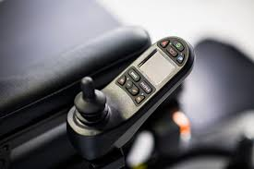

Fig. 1: joystick controller of electric wheelchair [1]

## 2) Existing Solutions

When researching aiding devices in the market, designed specifically for people who are severely disabled, one fails to find a practical solution. However, there are several solutions, utilizing innovative technologies, that are currently being discussed across research communities. One of these is creating a brain controlled wheelchair as discussed in [4]. As can be inferred by the name, brain controlled wheelchairs are systems that read, analyze, and utilize one’s brain signals as control commands to enable him or her to move a wheelchair accordingly. This can be generally implemented through Electroencephalography (EEG) monitors, which consist of electrodes, placed on one’s scalp to detect brain activity triggered by facial gestures or even specific thoughts. The readings of the EEG monitor are usually transferred to a brain computer interface (BCI) that can analyze the signals and send information to a microcontroller which moves the electric wheelchair. Another form of aiding systems are what is known by assistive home navigation. When embedded with such a system, a wheelchair would have the ability to become autonomous of its user’s commands in a familiar environment; in other words, minimal actions are required from the user to move the wheelchair within his or her household. One example of that is a system called NavChair, thoroughly discussed in [5], NavChair allows a wheelchair to perform several functions on its own without any maneuvering from the user, such as obstacle avoidance, door passage, and wall following. These functionalities are implemented through several preprogrammed algorithms within the wheelchair’s modified controller. This is just one example of assistive home navigation; nevertheless, other variations of autonomous wheelchair systems do exist. Unfortunately, these ideas and many more have been in the research phase for lengthy periods of time but rather none have been further developed and released in the market as consumer-friendly products.

## 3) Proposed Solution

Since some of the existing research ideas, brain controlled wheelchairs and autonomous home assistive navigation systems, have the potential of becoming promising and successful solutions for people living with extreme disabilities, the optimal aiding device would be one that combines both ideas into one system. The proposed solution is to create an Autonomous Brain Controlled Wheelchair. It would act as an add on system to any of the existing power wheelchairs in the market. Instead of having a wheelchair that can be regularly operated by a joystick controller, the modified wheelchair will have the ability to operate in two separate modes: a brain control mode, and an autonomous mode. The brain control mode would navigate the wheelchair through utilizing the user’s brain signals as discussed in the previous section. Of course, the process of obtaining brain signals would require the use of an EEG monitor or headset. Fortunately, there exists a number of EEG headsets of different brands that are available in the market. As for the second mode, the autonomous mode, it will mainly navigate the wheelchair with minimal guidance from the user in a familiar environment. To elaborate, since the use of brain signals may be cumbersome for some users, the autonomous mode would operate the wheelchair within the user’s household. The wheelchair will have to locate the user’s position and his or her desired destination, and drive the user with little to no interference from the user. This mode would require the wheelchair to be preprogrammed with the different routes which one can take within one’s household. The combination of these two ideas, creates a system that can provide people living with extreme disabilities, the independence and mobility of which they seek.

# II. Technology Used

## Overview

Before creating the prototype of the Autonomous Brain Controlled Wheelchair, extensive research was conducted to decide on the best technologies to be used in the project to ensure the optimum operation of the system once fully implemented

## EEG Headset

There are several brands of EEG headsets that are currently available in the market for both developers and consumers such as OpenBCI, Neurosky, and EMOTIV. Since the choice of headset plays a crucial role in the project, online research was conducted to attain a headset whose functionalities will be compatible with the project requirements. The list of potential EEG manufactures was narrowed down to: EMOTIV and OpenBCI. Table 1presents the pros and cons of each.

Table 1: OpenBCI versus EMOTIV

|  |  |  |
| --- | --- | --- |
|  | **OpenBCI** | **EMOTIV** |
| **Pros** | * Flexibility of signal processing * Free EEG raw data | * Short learning period * Auto signal processing |
| **Cons** | * Requires medical background to operate * Long learning period | * Subscription fee * No direct control over the signal processing |

From Table 1, it can be seen that EMOTIV’s headset does not require a lot of time to get familiar with and automatically performs signal processing. This is both an advantage and a draw back: on one hand, it reduces the time to complete the project (since a huge task is taken care of by the headset), but on the other hand, the signal processing algorithm is generic, and if one was to tweak it, he or she would need to pay a very expensive subscription fee. As for OpenBCI, it is very much open to developers when it comes to signal processing due to the fact that raw EEG data can be obtained free of charge. However, the downside of OpenBCI revolves around the fact that to be able to do the signal processing, some neurology background is needed, and therefore, more time is needed.

Although OpenBCI seems like the best option, EMOTIV was considered instead due to time constraints.

EMOTIV provides two solutions, namely EMOTIV EPOC+ and EMOTIV Insight, shown in [6, Fig. 2] and [7, Fig. 3], respectively. The EPOC+ has fourteen electrodes, or sensors, and therefore has higher resolution and can detect various brain signals; whereas, the Insight has only five electrodes, thus reducing the headset’s ability to detect more signals effectively. Due to budget constraints, the EMOTIV Insight headset (which costs $300) was considered over the EMOTIV EPOC+, even though the latter triumphs in every aspect.

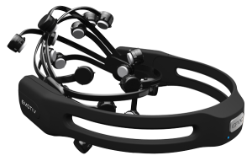

Fig. 2: EMOTIV EPOC+ headset [6]

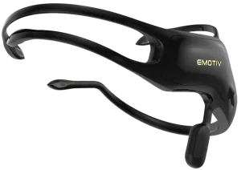

Fig. 3: EMOTIV Insight headset [7]

## Wheelchair

An electric wheelchair was needed in order to implement the project. However, since electric wheelchairs are expensive many hospitals and pharmacies were contacted hoping they would sponsor the project. The team members visited, emailed, and called some hospitals in Dubai and Abu Dhabi such as Saudi German Hospital, Mediclinic, Al Zahra, NMC, Zayed Military Hospital, Khalifa Hospital, and pharmacies such as Life Pharmacy. Some of the hospitals asked for an official letter from the university or for an email sent directly from the project supervisor. Even though all the requirements were provided, no replies were received from any of these hospitals. However, one reply was received from a doctor working at Sheikh Khalifa Medical Center, and they generously provided a used wheelchair.

## Microcontroller

The microcontroller used in the project was an Arduino microcontroller. The Arduino microcontroller is common for prototyping purposes, and the team is familiar with using it. Also, the Arduino microcontroller supports a range of accessories such as relay modules that are useful for multiple purposes. Unfortunately, the Arduino microcontroller is limited in processing power and memory. It only has one core, so multithreading is not possible. Nevertheless, the Arduino remained as the team’s best option as it does not require a learning curve, given the brief time period required for the project execution.

## Indoor Positioning

Part of the project involved making the wheelchair autonomous. This part heavily depends on knowing the user’s current location. A few technologies were considered in order to achieve that goal, namely, Beacons, Image Processing, and RFID.

### 5.1) Bluetooth Beacons

One potential way is to use Bluetooth Beacons. These beacons would be placed across the household. These constantly broadcast their identification number; if a device detects this message, the Received Signal Strength Index (RSSI) is determined and depending on that value and some algorithms, the position is approximated. The advantages of this technology are numerous:

* Infrastructure is easily found in the market
* Infrastructure is inexpensive
* Implementation is easy
* Accuracy offered for its price tag is excellent

While these advantages seem very appealing, the level of accuracy is of the order ±1.5m; as a result, this technology alone would not be enough to give the exact location. Indeed, according to Apple (pioneers in beacon technology) “iBeacon technology is not intended to be used for specific location identification. It should be capable of providing room-level accuracy [8].” Therefore, this technology was quickly ruled out.

### 5.2) Image Processing

To obtain the user’s current location, image processing was seen as a great alternative: a very distinguishable object (distinguishable color) was to be placed on the wheelchair, and whenever the user’s location was to be found, the cameras which would have been placed in the corner of the ceiling, take a snapshot. That image would then be sent to OpenCV (a powerful image processing tool), which would initially locate the wheelchair by locating the distinguishable object. From there, a code, based on the pinhole camera model, would have been written and the XYZ coordinates of the wheelchair would have been found [9].

While this technique seems ideal, given the time constraints and the monstrosity of the project, it was unfortunately ruled out.

### 5.3) RFID Technology

Finally, autonomy was implemented using Radio Frequency Identification (RFID) tags. These were placed in random places around the household, and whenever the user’s wheelchair went above a specific cluster tags, the Arduino microcontroller would then immediately recognize the tag and know that the user in location in x, for example. Depending on where his or her current location is, and his or her desired destination, the Arduino can guide the wheelchair to the final destination. While this way of implementing autonomy is very accurate, it completely relies on the number of RFID tags placed on the floor of the household: in order to know the user’s current location at any time, the user must land on an RFID tag. The fewer the RFID tags, the smaller the chances of determining the location at any time.

Given the time constraint of the project, RFID technology was considered and used for the implementation of the autonomous mode, although other technologies would have been better.

# III. Brain Controlled Mode

## Overview

As stated, the first and main part of the project is to make the wheelchair brain controlled. For that reason, the EEG headset was purchased. Nevertheless, due to the wheelchair’s inability to understand brain signals, several intermediate interfacing levels were added. Eventually, the aim is to have the EEG headset communicate with the wheelchair, via the Arduino Microcontroller. Fig. 4 displays all the steps that were taken in order to make the wheelchair brain controlled.

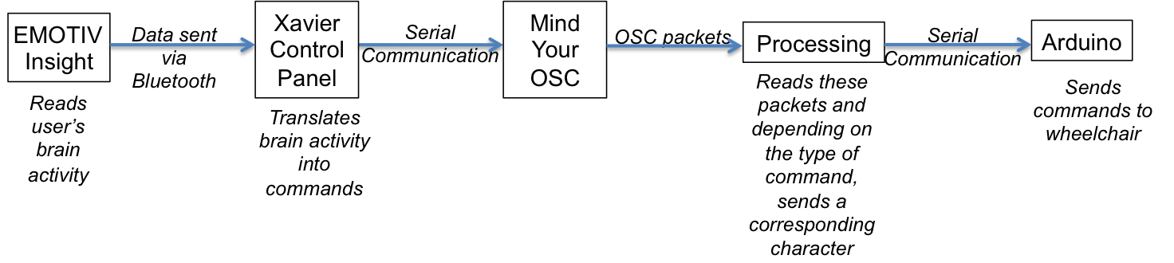

Fig. 4: Communication breakdown between user and wheelchair

## EEG – Microcontroller

### 2.1) Retrieval of Brain Signals

The first step in making the wheelchair brain-controlled is to extract the user’s brain activity, via the EEG headset. To be able to manipulate the brain signals coming from the user, an open-source software called Xavier Control Panel was used. This software receives the brain signals from the headset via Bluetooth and tries to decipher them.

Xavier Control Panel acts like a brain signal acquisition system: it reads the incoming signals and tries to associate it to a label (left, right or forward) given reference signals. That stated, the user must feed the system with as many reference signals as he or she can. The more the reference signals, the more accurate the signal processing. This step is repeated for the different commands that the user wishes to add. For instance, if the user wishes to have three brain commands (left, right and forward) then he or she needs to feed Xavier Control Panel with reference signals for each of these commands. This step of feeding the system with reference signals is called “Training”. Post training, Xavier Control Panel acts like a look up table: given a brain signal, it will find the brain command/label that resembles that input signal the most; in other words, post training, the system has the capability to distinguish the incoming data.

Fig. 5 shows the interface of Xavier Control Panel, where the user can choose the type of command he or she wishes to train. Xavier Control Panel gives the user the option to train up to five brain commands. Beyond five commands, Control Panel encounters a lot of issues deciphering the incoming data. That being said, even with three brain commands, the signal processing is not accurate and takes a lot of time.

Unfortunately, no further information regarding the signal processing is shared by the EMOTIV for confidentiality reasons.

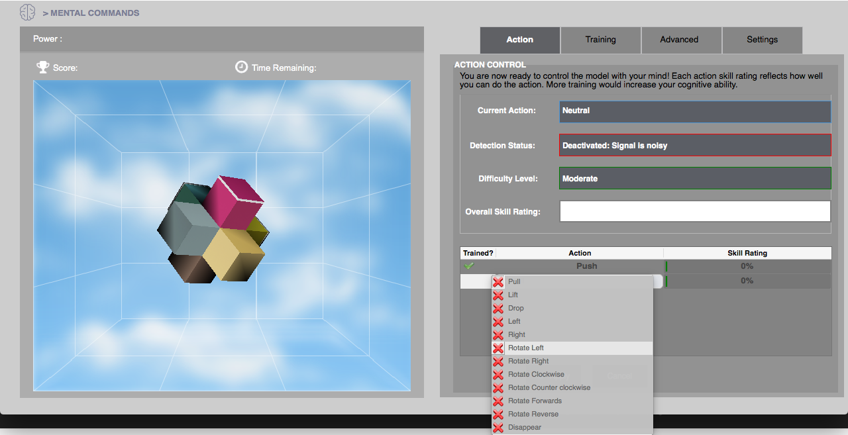

Fig. 5: Xavier Control Panel user interface

### 2.2) Sending Data

Xavier Control Panel processes the incoming signal and detects it as “left”, “right”, “forward” or “neutral”. The next step is to share this information with an Arduino Microcontroller. However, due to the lack of compatibility between these two, there is no direct way of doing this step. That being said, in order to get the data from the Xavier Control Panel to the Arduino microcontroller, an intermediate software was used: namely, Processing.

#### 2.2.1) OSC Messages

Xavier Control Panel has the ability to send data as an Open Sound Control (OSC) message. According to the Center for New Music and Technologies (CNMAT), OSC initially started as a protocol for networking sound synthesizers, but later expanded to become a communication protocol for any devices sharing a common network. OSC uses a protocol called User Datagram Protocol (UDP), which operates in the “Transport” layer of the OSI model. This layer is responsible for the host-to-host communication: given a message, a source port, a destination address and a destination port, the message gets delivered from one port to another. The destination address corresponds to the IP address of the receiver: the receiver could be the same computer or could be any computer on the same network. Due to the fact that this protocol is port-to-port based, both devices must be connected on the same network. All OSC messages share the same format, shown in Fig. 6.



Fig. 6: OSC message format

The *address pattern* holds the description of the incoming message: where the incoming message is coming from, as well as the nature of the message. The *type tag string* specifies the type of incoming message: 32-bit integer, 32-bit float, strings, time tag, array of bytes (blob). The *Argument* is the content of the message [10]. Table 2 displays the message breakdown of an OSC message sent from Xavier Control Panel.

Table 2: Xavier Control Panel OSC message breakdown

|  |  |
| --- | --- |
| **Address Pattern** | /COG/XXXX/ |
| **Type tag String** | Float |
| **Arguments** | Float number ranging from 0.0 to 1.0 |

From Table 2, the only varying part of the address pattern is the part of the message that follow “/COG/”. Indeed, it is this part of the message that holds the user’s command: the “XXXX” can either be “LEFT”, “RIGHT” or “PUSH” (or forward). The float number that follows the address pattern corresponds to the power of the signal. The power of the signal is a value, which translates the correlation of the incoming signal to the reference signals of one command.

#### 2.2.2) Processing

To be able to send this data, Mind Your OSC, software that came along with EMOTIV’s Software Development Kit (SDK) has the ability to send this OSC message to a device in the network given its IP address and a free port.

The Arduino IDE unfortunately does not support OSC messages; as a result, Processing was chosen to be the intermediate node between Mind Your OSC and Arduino*.* Indeed, Processing*,* on one hand, has the ability to receive OSC messages, and on the other hand, has the ability to communicate with Arduino.

Fig. 7 shows a snapshot of Mind Your OSC*:* due to the fact that the communication is done within the same computer, the local host (127.0.0.1) was the transmitter’s and the receiver’s IP address. The choice of ports does not matter, as long as the ports are not used by any other application.

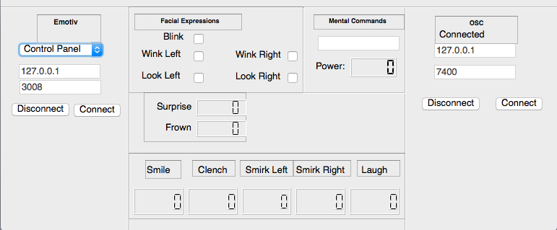

Fig. 7: Mind Your OSC interface

From Fig. 7, it can be determined that Mind Your OSC, sends OSC messages to the computer’s port number 7400. As a result, the Processingsketch should listen to incoming messages through this port: line 17 of the sketch shown in Fig. 8 takes care of that. If an incoming OSC message has “/COG/PUSH/” or “/COG/LEFT” or /COG/RIGHT” then the power of the signal is retrieved, and the power is above a threshold of 0.75 (chosen arbitrarily), then Processing gives the command to Arduino to turn the wheelchair in a specific direction (determined by the address pattern). To be able to send data to Arduino, port number 9600 should be used: this is shown by line 16 in Fig. 8.

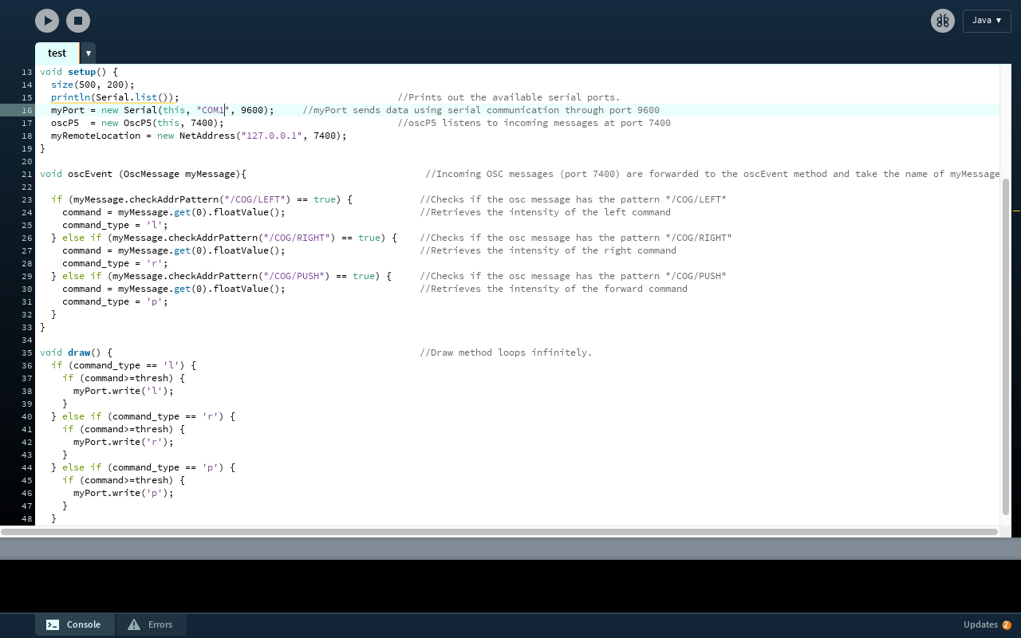

Fig. 8: Processing sketch

#### 2.2.3) Arduino

To ensure the validity of the Processing code the was created in Fig. 8. A simple Arduino sketch, that receives serial data from Processing was written. To elaborate, based on the type of mental command and its corresponding threshold, a specific character was sent to the Arduino sketch. Based on the character that was received, a specific LED would start blinking. With the small success of having the user of the headset generate a brain signal that would eventually cause an LED to turn on, the communication link between the EEG headset and the microcontroller was well established. From there, the microcontroller-wheelchair subsystem was developed.

## Microcontroller – Wheelchair

### 3.1) Overview of Proprietary Controller

The main goal, in this part of the project, was replacing the wheelchair’s joystick with the Arduino Microcontroller to be able to simulate the movement of the joystick using the Arduino; hence, programming the wheelchair’s movements. However, it was noticed that whenever the wheelchair is turned on, the wheelchair controller runs a security check to verify that the joystick is actually connected. Luckily, a loophole was found in this process which enabled the team members to bypass the controller. Secondly, the wheelchair controller is connected to the joystick through seven pins, and there were no data sheets available on the controller’s official online website. More on these challenges and how they were solved is found in the following section.

### 3.2) Bypassing the Controller

To begin with, the wheelchair controller has a deep dependence on the proprietary joystick. Fortunately, this security check has a loophole. After the start-up security sequence, the controller can take custom commands if the voltage on pins 2, 4, 5, and 7 are matched with the joystick. By connecting a custom voltage changing circuit, the controller assumes that the joystick is connected. Furthermore, a relay module controlled by the Arduino is used to facilitate switching modes between the joystick and the custom circuitry to change the voltage level. Two relays are used to switch between the joystick signals and the custom circuit signal, and four relays are used to short the resistors to vary the voltage level between High and Low. Fig. 9 shows the circuit diagram of the interface.

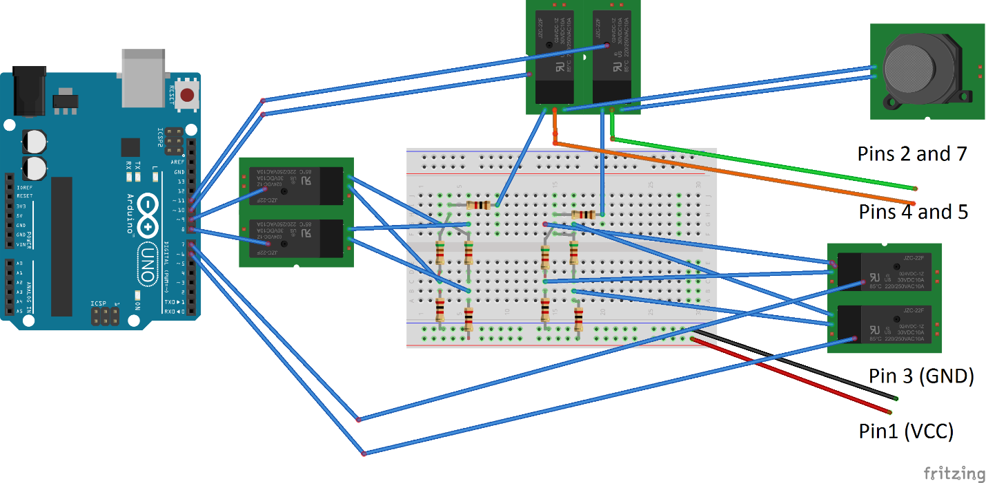

Fig. 9: Custom circuit diagram

Moreover, there was no data sheet for the pins connecting the controller to the joystick. Therefore, a multimeter was used in order to observe each pin as the direction of the joystick is changed. It was noticed that pins 2, 4, 5, and 7 are responsible for movement, and their signal voltage changes according to the direction. Pin 1 is connected to VCC, pin 3 is connected to ground, and pin 6 is connected to the centre voltage (VCC/2). Pins 2, 4, 5, and 7 are responsible for movement. Table 3 shows the signal voltage on the seven pins when the wheelchair is not moving, and when it is moving in any direction.

Table 3: The signal voltage on the seven pins when the wheelchair is both stationary and moving

|  |  |  |  |  |  |
| --- | --- | --- | --- | --- | --- |
|  | **Pin1** | **Pin2/7** | **Pin3** | **Pin4/5** | **Pin6** |
| **Fixed Position** | 5v | 2.5v | 0v | 2.5v | 2.5v |
| **Left** | 5v | 3.8v | 0v | 2.5v | 2.5v |
| **Right** | 5v | 1.2v | 0v | 2.5v | 2.5v |
| **Forward** | 5v | 2.5v | 0v | 1.2v | 2.5v |
| **Backward** | 5v | 2.5v | 0v | 3.8v | 2.5v |

### 3.3) Arduino

Custom Arduino libraries were built to facilitate the usability of the wheelchair. The libraries allow adding new features to the project without too much interference from the users. The code for the libraries is included in the appendix section of the report. The library created for the wheelchair’s brain control mode is called Wheelchair. Some of the features this library supports are basic movement functions. The functions are all time based, so the user can precisely control the wheelchair for different situations. The functions run without delays therefore, multiple commands can be executed. After creating the library, and writing a corresponding Arduino sketch, the wheelchair was successfully moved using specific keystrokes. This marked the end of creating the individual subsystems, from there these systems were integrated to create a brain controlled wheelchair.

## Integration

The integration of the two subsystems required connecting the Processing sketch created earlier with the Arduino sketch that included the Wheelchair library. In brief, the Processing sketch must send a specific character to the Arduino, based on the mental command retrieved from the user. From there, the character that the Arduino receives, indicates the direction of which the Arduino must move the wheelchair in.

Even though the set up between the two subsystems was quickly established, some issues were faced. The problems were closely related to the EEG headset. The first challenge was quickly observed during the EEG-Wheelchair testing trials. It was noticed that the wheelchair can be perfectly controlled with two mental commands, which were trained for and saved on the Xavier Control Panel. However, whenever a third command is added to the user’s training profile in the software, the wheelchair’s movement becomes erroneous, mainly moving in one direction as it only detects one of the three mental commands. It was deduced that this issue is caused by the inaccuracy of the EEG headset since the EMOTIV Insight is constructed of five electrodes only.

This issue did not have a clear solution, as buying another headset at that phase of the project was out of the question, but several alternatives were discussed. The first alternative stemmed from the fact that the Insight headset could detect facial expressions. Since two mental commands, corresponding to two directions, could be perfectly distinguished, it was considered to control the wheelchair using two mental commands and a facial expression that will correspond to the third direction. However, this idea was soon dismissed when tested because the team noticed that the headset reads mental commands and facial expressions simultaneously, this is shown in Fig. 10, in a snapshot of Mind Your OSC. This situation caused a problem when the messages were sent to Processing as it continuously read OSC messages from Mind Your OSC. Errors mainly occurred when the user tried to switch between generating a mental command and a facial expression quickly. For instance, when a person ceases to think of a specific mental command, the readings of the command would be decreasing, and when he or she starts to create a facial expression, the readings of the brain signals generated by the facial expression would be increasing. In this case, Mind Your OSC will keep sending two different messages one after the other causing Processing to send two different characters to the Arduino which will in turn move the wheelchair erroneously.

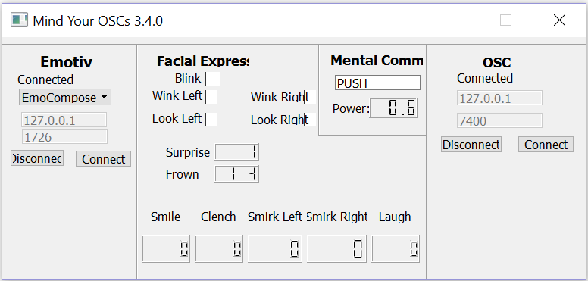

Fig. 10: Snapshot of Mind Your OSC reading a mental command and a facial expression

The second and chosen alternative was to create a GUI that will allow the user to control the wheelchair with two mental commands only. To elaborate, the GUI, created using Processing and seen in Fig. 11, has four buttons for generating the wheelchair’s movement. The user must use one mental command, for example think of going left, to select a button, and when the user thinks of the command again the next button will be selected and so on. To confirm the selection, the user must use another mental command, for example moving forward.

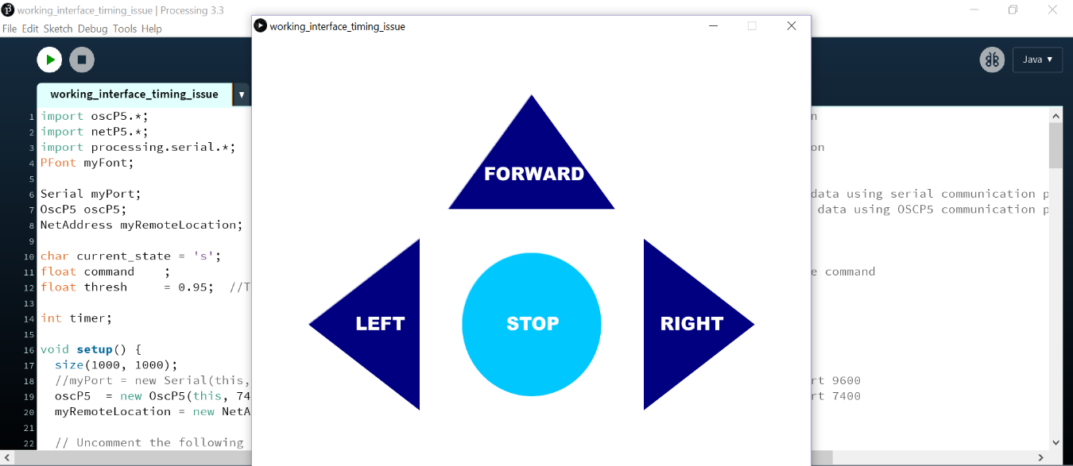

Fig. 11: Brain control mode GUI

During integration, another minor issue was faced and quickly resolved. As mentioned earlier, the wheelchair movement is implemented by varying voltage levels on certain pins. This approach cause some issues because the wheelchair controller is sensitive to slight voltage variations. Consequently, the wheelchair moves slightly to the left when moving forward due to voltage inaccuracies. To combat this, a correction function was created and made the wheelchair tilt to the right at a certain time interval.

By completing the integration process, the wheelchair was capable of fully operating in brain control mode.

# IV. Autonomous Mode

## Overview

Since the first part of the project was completed, the team’s full aim was to decide on the overall specifics of the autonomous mode, create the key features of the system, and add modifications during the testing process. The subsystems described in the next sections of the report provide an insight on the mechanisms of the autonomous mode.

## Autonomy Systems

### 2.1) RFID

The team aimed to map the user’s house using RFID tags organized as clusters in every room. Whenever, the wheelchair passes on a specific RFID “carpet” a question is prompted to the user asking him or her where he or she wishes to go. The subsystem, was to install an RFID reader on the bottom of the wheelchair, and have it as close as possible to the floor, to have it detect the tags accurately. Once an RFID card is detected the Arduino microcontroller updates its current location, and it informs Processing. The RFID module used for the Arduino microcontroller is relatively cheap and implementable. The RFID approach was good for demoing purposes; however, if more time was allocated, the team would have implemented this functionality using image processing.

### 2.2) Interface

If the wheelchair is to become a home assistive navigation system, the user should be able to go from one point to another by just choosing his or her desired destination. Therefore, a GUI had to be created to ease the communication between the user and the wheelchair. However, before creating the interface, the system layout was decided. There are three main points in the house (A, B, and C), and for each of these, there is a cluster of RFID tags. Whenever an RFID tag is detected, a specific letter will be sent to the Processing sketch depending on the location. For example, if the wheelchair stops at point A, the letter A will be sent from the Arduino sketch, detecting the tag, to Processing. This will first trigger a question asking the user whether he or she wants to switch to the autonomous mode as shown in Fig. 12.

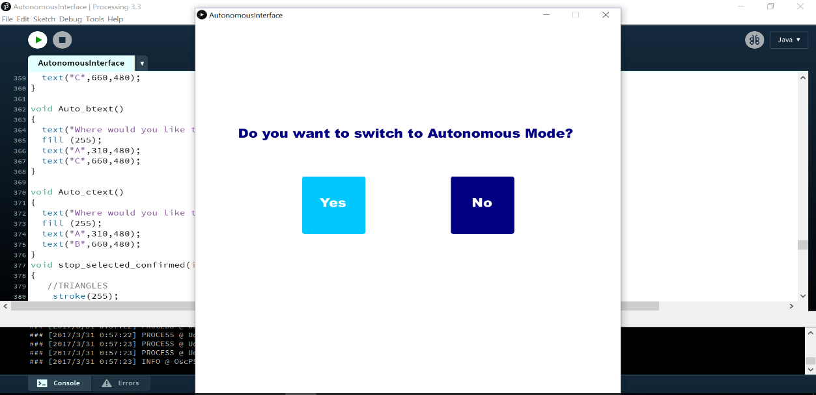

Fig. 12: Snapshot of the autonomous mode GUI (beginning of autonomous mode)

The user must use one mental command such as moving left to select one of the buttons, yes or no in this case. To confirm the selection, the user thinks of a different mental command, for example push. If the user chooses that he or she does not want to go into autonomous mode, the interface will go back to the brain controlled mode and a specific letter will be sent to the Arduino, “n” for example; however, if he or she chooses yes, then the next question will be prompted depending on which point the user is already at. If the user is at point A, the question will be asking the user to choose between two points which are B and C in this case. An example is shown in Fig. 13. The process used for selecting and confirming the answer using mental commands is the same as the one used for the previous question. When the answer is selected, it will appear in light blue, and then when it is confirmed, it will turn to gray. Then a character will be sent to the Arduino, indicating the destination to which the user wants to go. Then once the destination is reached, the Arduino will send a specific character, after which the Processing interface will go back to brain control mode.

Several coding challenges were faced. However, when debugging, the GUI eases the process as one can visually detect the issues in the code. One of the problems faced was that there had to be a clear distinction of when the interface should switch between BCI and autonomous mode. To elaborate, sometimes the interface would show the question asking to switch to autonomous mode while BCI mode is still on, as seen in Fig. 14. This problem was quickly resolved using a number of Boolean variables that would be reset before and after switching to any of the two modes. A copy of the final Processing code can be found in the Appendix section of the report.

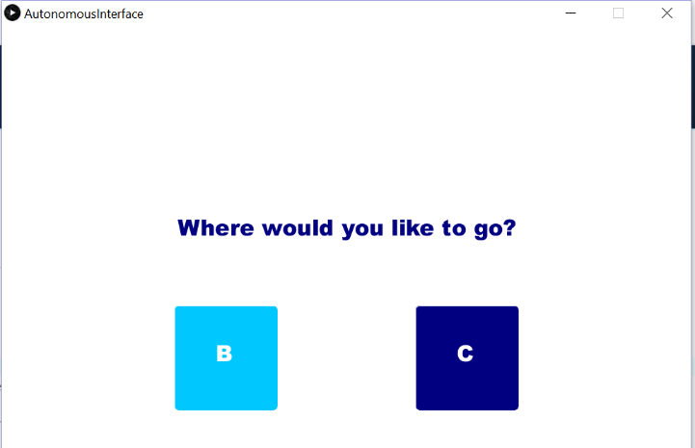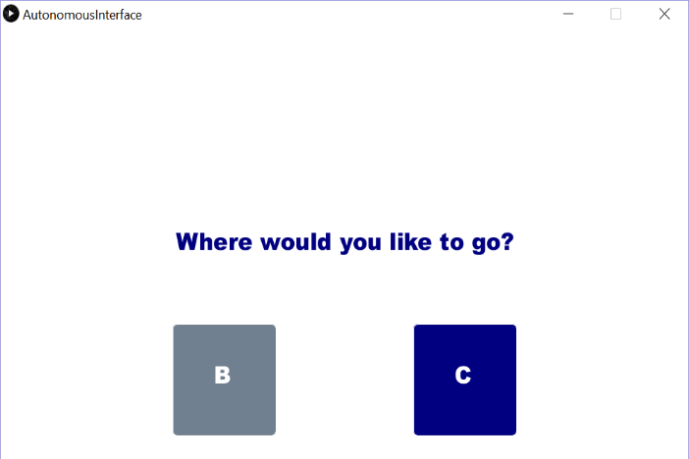

Fig. 13: Snapshot of autonomous mode GUI (cluster A is detected)

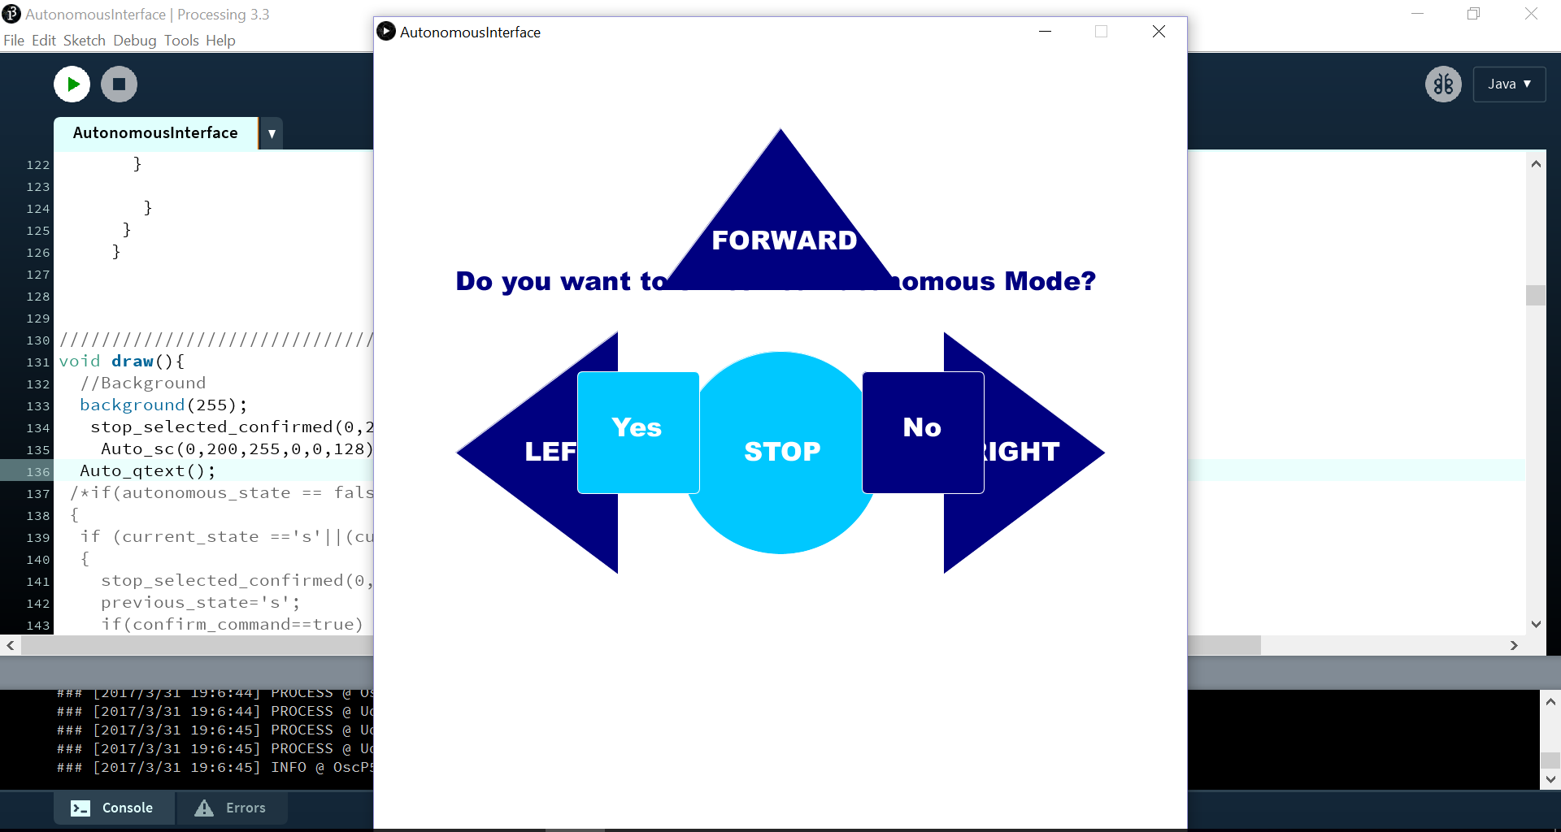

Fig. 14: Buggy Processing code (Interface)

### 2.3) Compass

Due to the fact that the wheelchair can land on the RFID carpet in any direction (north, south) and the wheelchair library built is time-based (move forward for x amount of seconds), if the wheelchair’s initial orientation (pointing south instead of pointing north, for instance) was wrong, then the wheelchair will never reach its intended destination. From the need to know the wheelchair orientation, the need to initially fix it according to the destination was born. To fill in that necessity, the idea of introducing a compass on board to the wheelchair system was introduced.

To further illustrate, the example shown in Fig. 15 is considered: the wheelchair landed on the RFID carpet for destination A, and the user wishes to go to destination B. If the user is facing the North direction, and there is no algorithm to correct his or her orientation, then the wheelchair will not reach its destination.

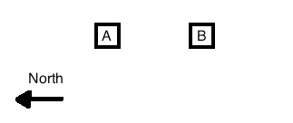

Fig. 15: Scenario demonstrating the need of a compass

Given the destination of the wheelchair, the orientation of the wheelchair should change accordingly. To rotate the wheelchair to be in the correct direction, a compass was installed.

#### 2.3.1) HMC5883L

The HMC588L module is a chip manufactured by Honeywell, shown in Fig. 16: it acts as a 3-Axis Digital Compass. This module was initially considered to be installed on the wheelchair due to the ease of interfacing it with Arduino. However, an issue presented itself when using this module: the HMC5883L integrated chip is extremely sensitive to variations in the magnetic field [11]. For instance, if a wire carrying current was around the chip, then the chip outputs erroneous values for the compass heading. To demonstrate how erroneous the chip is, a test was conducted: one of the team members held the module and moved in a straight line, in a room full of wires, computers and servers, and the graph displayed in Fig. 17 was obtained.

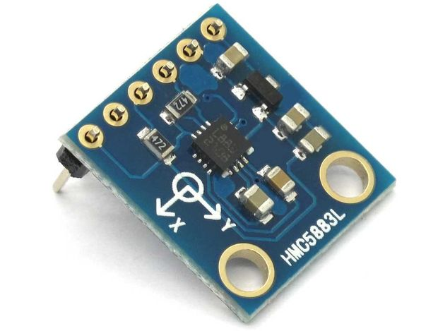

Fig. 16: HMC588L Digital Compass

Fig. 17: Fluctuations in the reading of the HMC588L Digital Compass

This graph shows how unreliable this compass is: over a distance of less than 15 meters, the compass’ reading went from 195° to 187° to 207°.

#### 2.3.2) iOS Application

While the HMC588L chip is beyond sensitive to noise, the iPhone’s digital compass is less, may be totally, immune to noise. This was determined by performing the same test mentioned in 2.3.1, in the same location. The results were remarkable, as the iPhone’s heading deviated only by ±2°. From there, the decision to use the iPhone’s compass came. However, a challenge presented itself: how to send the compass heading from the iPhone to the Arduino. Having worked with OSC messages, and having recognized its potential, the team thought of creating an iOS application, which would get the compass heading and send the data as an OSC message to Processing and then to Arduino.

There are two main steps in making this app: the first one is to get the compass heading and the second one is to send it as an OSC message. The first part was easily completed since there are many codes in the iOS Developer’s community that do this. That stated, a functioning code giving the compass heading was found on *Stack Overflow* [12];that code was then modified to send the heading as an OSC message to any computer in the same network. Unfortunately, this step was proven to be heavy due to the fact that most the existing libraries that support OSC messages on iOS were not any more compatible with the newly updated Swift language (iOS programming language). After a lot of research, the only library that came close to working was a library called “BuzzOSC” [13]. After a few modifications to the library and the compass code, “El Magnetico” app was found and successfully sent the compass heading from iPhone to Processing. A screenshot of the app can be seen in Fig. 18.

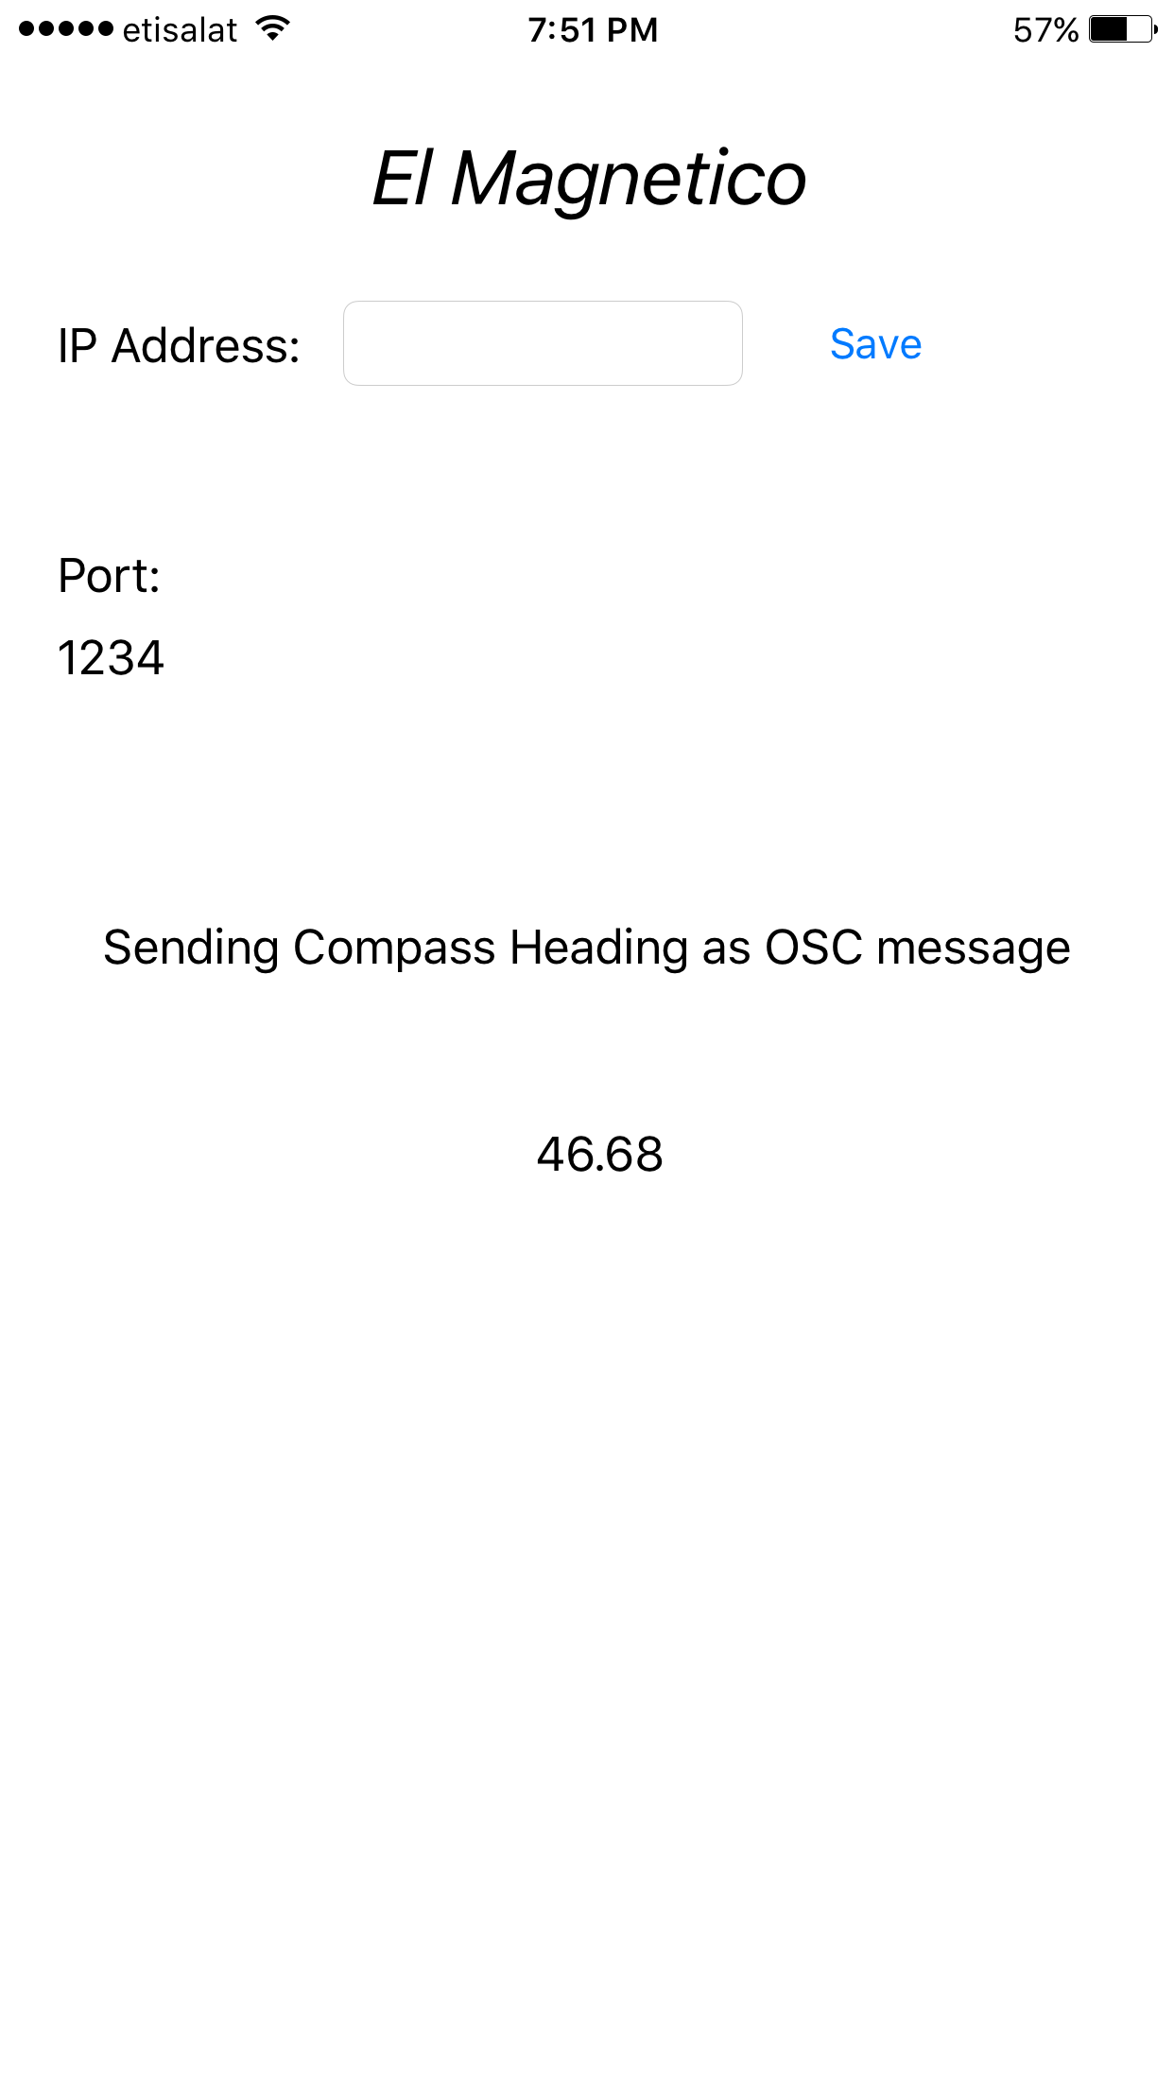

Fig. 18: El Magnetico app

This application constantly sends as an OSC message containing the iPhone’s heading: the message pattern is “/compass/”, the data type of the compass heading is a float, and the argument is as expected, the compass heading. The float number was however later converted to an integer, for ease of manipulation.

In order to correct the wheelchair’s orientation, Arduino sends to Processing the ideal heading, and Processing compares that value to the one it is reading from the iPhone’s compass. If the wheelchair is deviating to the right, Processing will send the command to Arduino to go to the left, until the wheelchair’s heading, obtained by the iPhone, is within an acceptable threshold.

### 2.3) Motion Sensor

Obstacle detection, an important feature necessary for safety and maneuverability, was added to the wheelchair as a subsystem. Obstacle detection was implemented in the project using four HC-SR04 ultrasonic sensors. These sensors measure distance by using two pins Trigger and Echo. The Trigger pin sends a pulse that gets reflected off objects. Consequently, the Echo pin detects the reflected pulse. The distance is calculated based on the time the pulse traveled from the Trigger to The Echo. Four sensors were placed on the wheelchair; hence, four Trigger and Echo pins were needed. Two sensors were used to detect obstacles in front of the chair. Two sensors were used to detect obstacles on the left and right sides of the chair. The team assumed that the user will not need a sensor when moving backwards because the user will not be moving backward. The arrangement and connections of the sensors are shown in Fig. 19. Furthermore, the sensors were interfaced using a function from the Wheelchair library called ReadSensorInput. Fig. 20 shows part of the function code. As mentioned earlier, the Trigger pin is set high for five microseconds then low to send a pulse. Then, the echo pin measures the duration using the pulseIn function. Finally, this duration is converted to centimeters using the microsecondsToCentimeters function. The code proceeds to stop the wheelchair should the user approach an obstacle such as a wall.

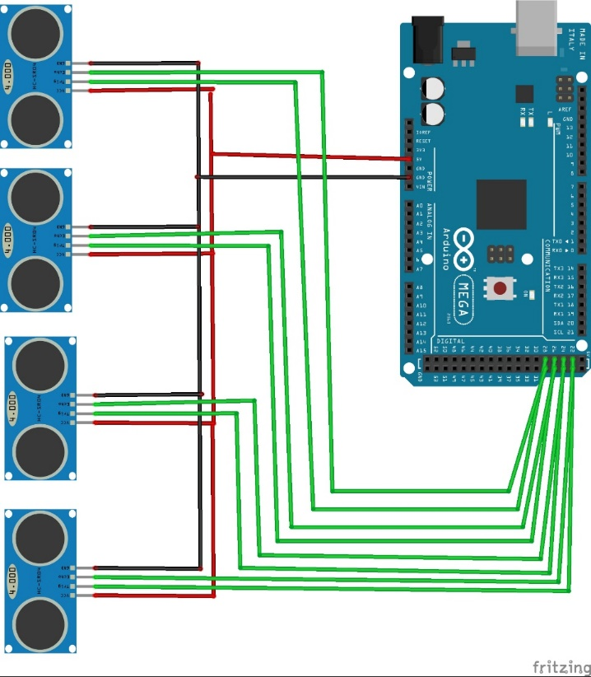

Fig. 19: Sensor circuit diagram

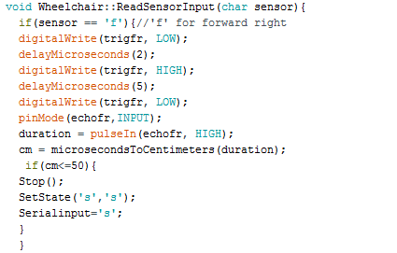

Fig. 20: Section of the sensor function as written in the Arduino Wheelchair library

## 3) Integration

There were many challenges faced while integrating the autonomy phase of the project. Some of them were related to Processing. The first one was that the interface would not go back to brain control mode after reaching the end of the preprogrammed path, indicated in the code by receiving the character “Z” from the Arduino. Although there was an if statement stating that whenever “Z” is read, the interface should go to brain control mode; however, this if statement was checked in the brain controlled mode which resulted in not checking the condition while the code is in the autonomous mode. This was solved by adding an else if statement. First the system checks if there is an “A”, “B”, or “C” received, if not, it checks if “Z” is received. The second challenge was that the process of writing to the Arduino sketch, occurred before in the code in the OSC event function which means that it will be running all the time, so Processing will keep sending the destination letter until “Z” is received. This was causing a problem on the Arduino side because every time the letter is received, it resets the counter used to time the preprogrammed path being travelled. This issue was solved by adding a boolean expression that goes false after sending once and it goes to true only after a neutral command is received. This boolean expression must be true in order to write the destination to the port. Another challenge faced was related to the user’s safety. In order for the user to stop, he or she had to select the stop button first and then confirm it. This process would take a long time to move from one button to the other and is not practical. Therefore, the team members have decided that whenever neutral is received by Processing, “s”, which is the command for stop, is sent to Arduino. This makes the user safer on the wheelchair, and he or she can easily control it and stop it whenever desired, which in result makes the interface more user friendly.

Moreover, there were challenges faced related to the Arduino. One of them was because of the ultrasonic sensors that were used to avoid obstacles. Unfortunately, the sensors need a delay of seven microseconds to get an accurate reading. Modifications to the code were made to accommodate this issue because the library does not tolerate delays. Furthermore, a simple algorithm was developed to facilitate turning left and right on corners. The Arduino compares the input from the sensors, then it proceeds to move in the area with the freest space.

To simplify the integration of new subsystems in the autonomous mode in the future, a second library called Autonomous Wheelchair was created. The functions this library supports are defining locations using RFID cards and a reader. A database of the RFID cards is also implemented in this library. Another feature the library supported was the digital magnet module for Arduino. This feature is disabled because the module was not usable due to the issues discussed earlier in section 2.3.1. It is worth mentioning that disabling features from libraries does not affect the experience of the user because the libraries are built to be modular.

This marks the end of the autonomous mode; hence, the wheelchair is now capable of being operated in brain control mode and autonomous mode.

# V. Project Roadmap

## 1) Time Management

In order to deliver the brain controlled electric wheelchair using EEG signals working prototype within the 15 weeks, the project had to be divided into tasks. Next, a Gantt chart showing the different tasks as well as the corresponding duration is shown in Fig. 21. The Gantt chart had to be modified due to the delay that happened in receiving the headset and the wheelchair. They were supposed to be received on week 4; however, they were received on week 6. Therefore, the team members decided that instead of working on the two phases of the project simultaneously to focus on the first phase, and then start working on the second once the first one is over. The project was over however completed on the scheduled time. It took a total of 14 weeks to research the project, implement it, and present a working prototype.

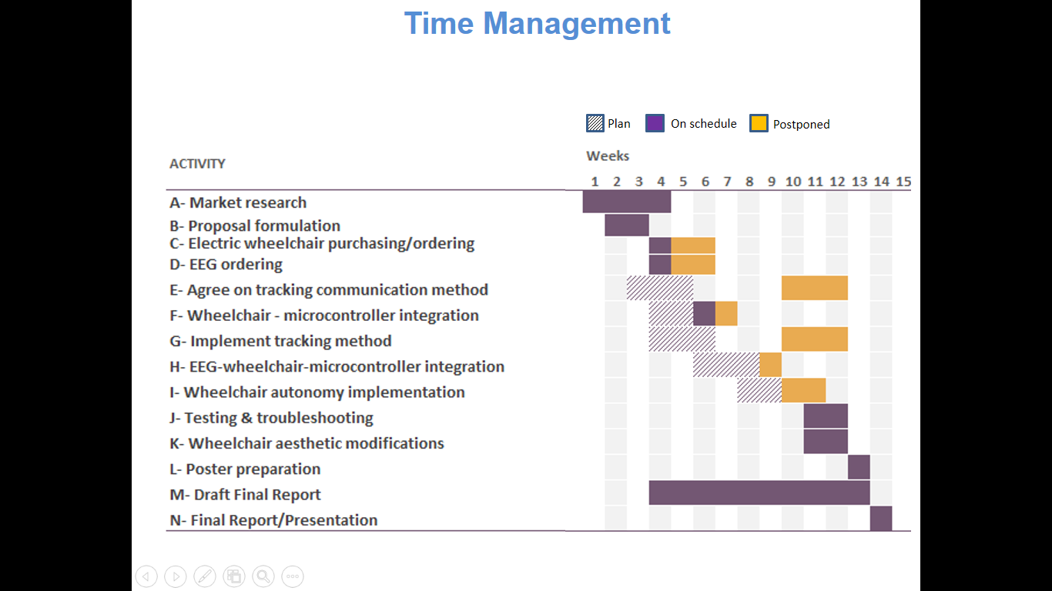

Fig. 21: project Gantt chart

## 2) Budget Management

As for the budget, the main costs were related to the wheelchair and the purchase of the EEG headset. As mentioned before, the wheelchair was generously donated; however, the batteries had to be replaced. Some other communication system components were needed for the autonomous phase such as RFID tags, RFID reader, microcontroller, etc. The budget spent on the project is shown in Table 4.

Table 4: Project budget

|  |  |
| --- | --- |
| **Item** | **Cost** |
| Wheelchair Batteries | $410 |
| EEG Headset + Shipping | $370 |
| Communication System Components | $40 |
| **TOTAL** | **$820** |

# VI. Future Plans

In conclusion, the autonomous brain controlled system is only a prototype that was created over the course of four short months; however, if implemented in the market, it can have a significant impact on a lot of people’s lives. Moreover, the system can be further modified by integrating other technologies such as the use of image processing in the autonomous mode as discussed in earlier sections of the report. Furthermore, it can be tested with a more accurate headset to improve the overall experience of the user and much more. For these reasons, the team plans on further developing the project through longer periods of time, in the hopes of creating a long term product that can act as an add on system to the insufficient electric wheelchairs available in the market.

# VII. References

[1] “Wheelchair Controls - Magic Mobility Electric Chairs - Powerchairs,” *Magic Mobility.* [Online]. Available: https://www.magicmobility.com.au/wheelchairs/wheelchair-options/wheelchair-controls/. [Accessed: 22-Jan-2017]

[2] “Better health for people with disabilities: infographic,” *World Health Organization*. [Online]. Available: http://www.who.int/disabilities/infographic/en/. [Accessed: 22-Jan-2017].

[3] R. C. Simpson, “How many people would benefit from a smart wheelchair?” *The Journal of Rehabilitation Research and Development*, vol. 45, no. 1, pp. 53–72, Jan. 2008.

[4] T. Carlson and J. D. R. Millan, “Brain-Controlled Wheelchairs: A Robotic Architecture,” *IEEE Robotics & Automation Magazine*, vol. 20, no. 1, pp. 65–73, 2013.

[5] R. Simpson and S. Levine, “Automatic adaptation in the NavChair Assistive Wheelchair Navigation System,” *IEEE Transactions on Rehabilitation Engineering*, vol. 7, no. 4, pp. 452–463, 1999.

[6] “EMOTIV Epoc - 14 Channel Wireless EEG Headset,” *Emotiv*. [Online]. Available: https://www.emotiv.com/epoc/. [Accessed: 24-Jan-2017].

[7] “EMOTIV Insight Brainwear® 5 Channel Wireless EEG Headset,” *Emotiv*. [Online]. Available: https://www.emotiv.com/insight/. [Accessed: 24-Jan-2017].

[8] “Getting Started with iBeacon,” *Getting Started with iBeacon*. Apple, 2014.

[9] “Camera calibration With OpenCV,” *OpenCV*. [Online]. Available: http://docs.opencv.org/2.4/doc/tutorials/calib3d/camera_calibration/camera_calibration.html.

[10] “Open Sound Control (OSC),” *McGill*. [Online]. Available: https://www.music.mcgill.ca/~gary/306/week9/osc.html. [Accessed: 15-Feb-2017].

[11] “3-Axis Digital Compass IC HMC5883L,” *Adafruit*. [Online]. Available: https://cdn-shop.adafruit.com/datasheets/HMC5883L_3-Axis_Digital_Compass_IC.pdf. [Accessed: 04-Mar-2017].

[12] M. Spoon, “Finding the compass orientation of an iPhone in swift,” *Stack Overflow*, 08-Jun-2015.

[13] J. Mars, “BuzzOSC,” *GitHub*, 2015. [Online]. Available: https://github.com/marsman12019/buzzOSC. [Accessed: 02-Apr-2017].

**Appendix A**

**Arduino Library and Code**

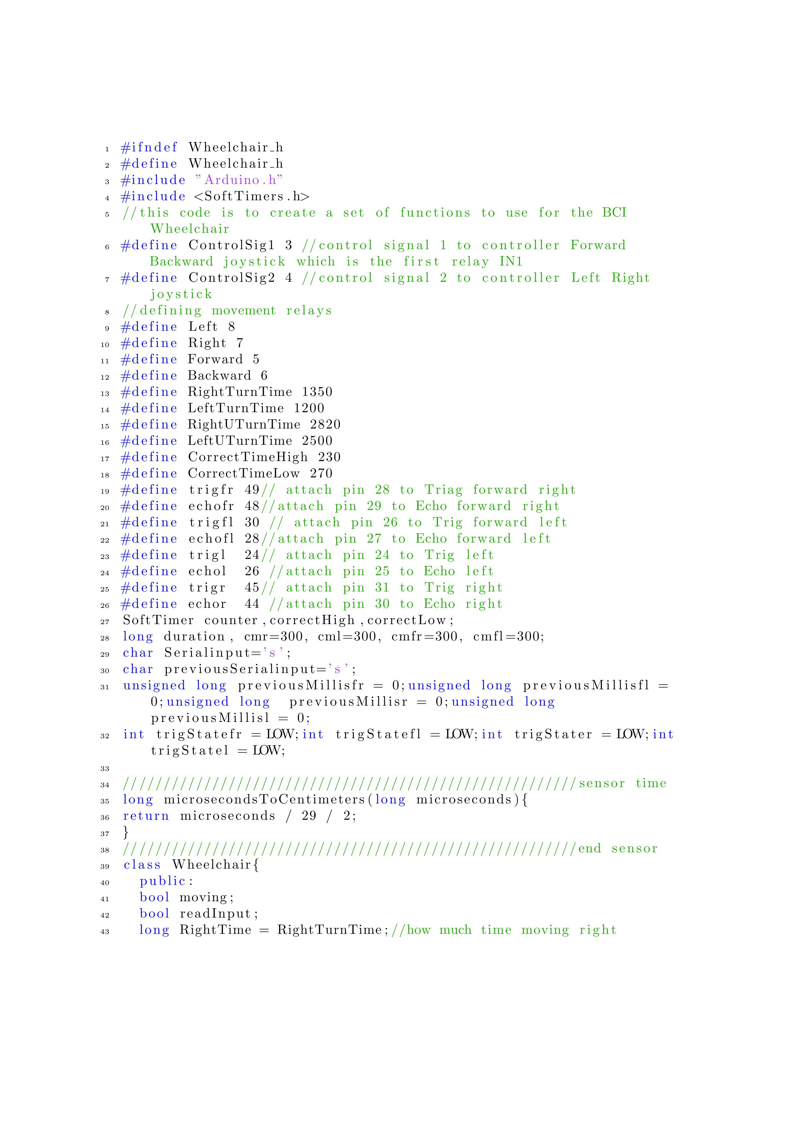

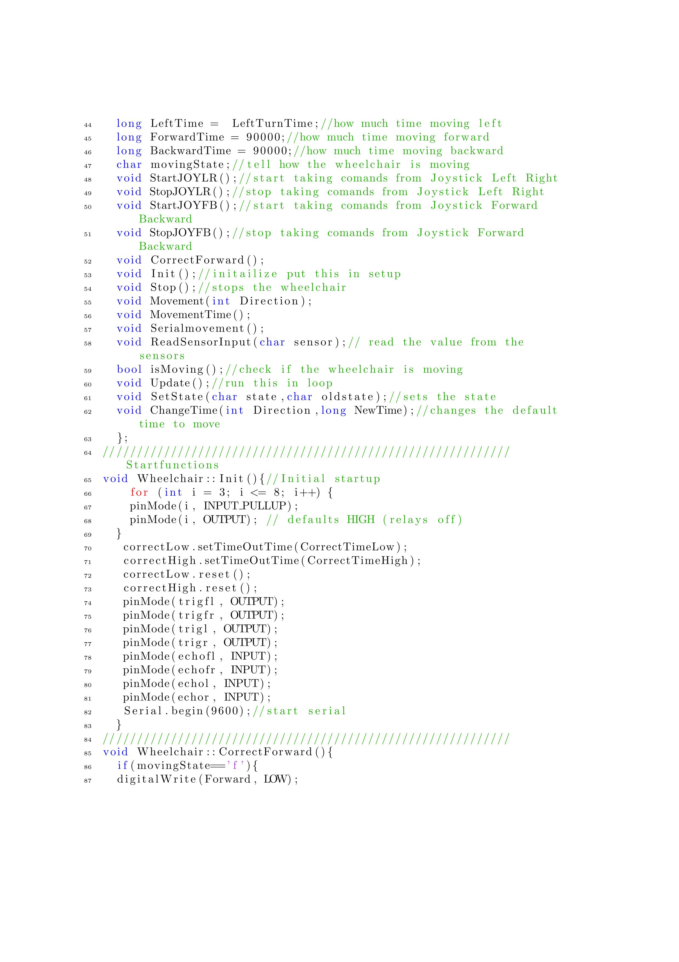

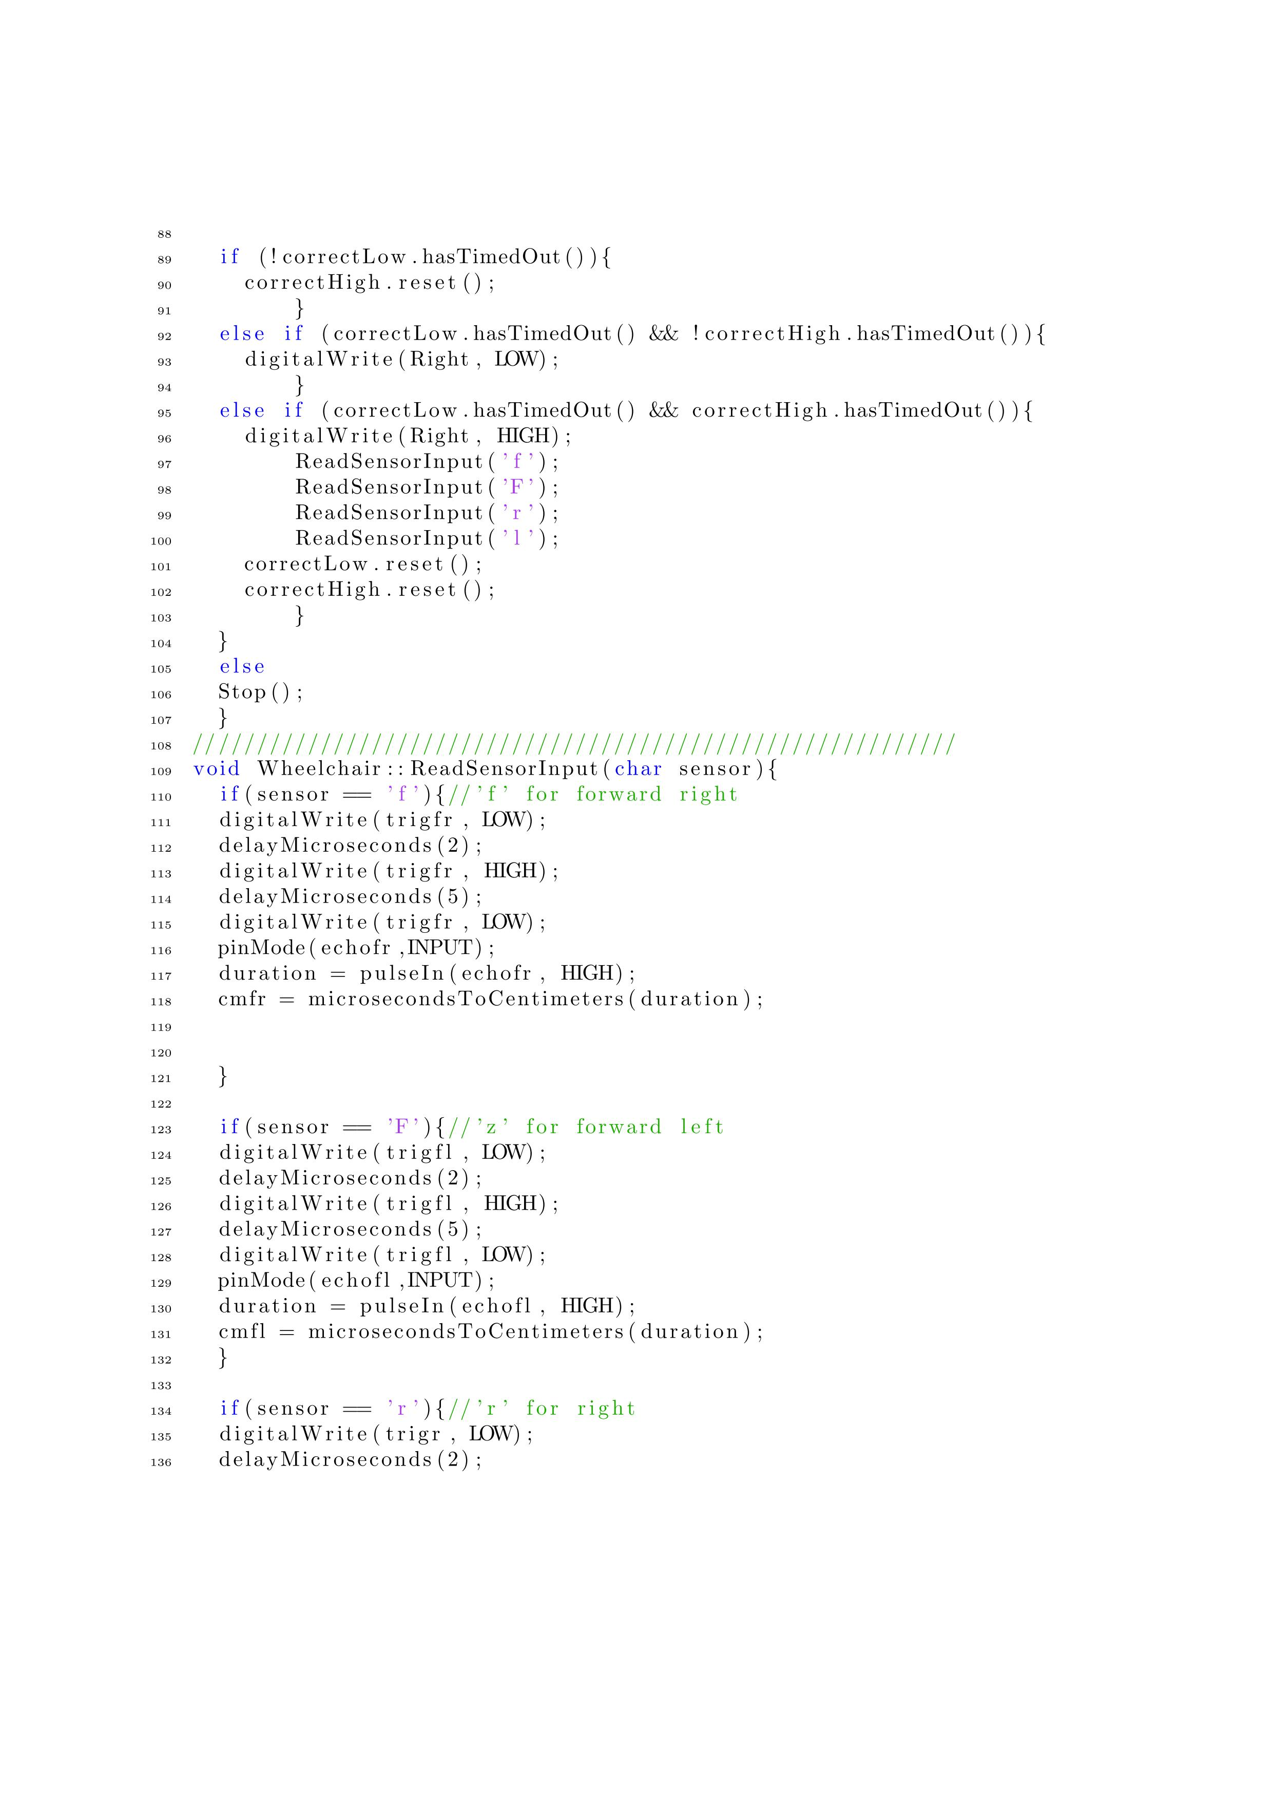

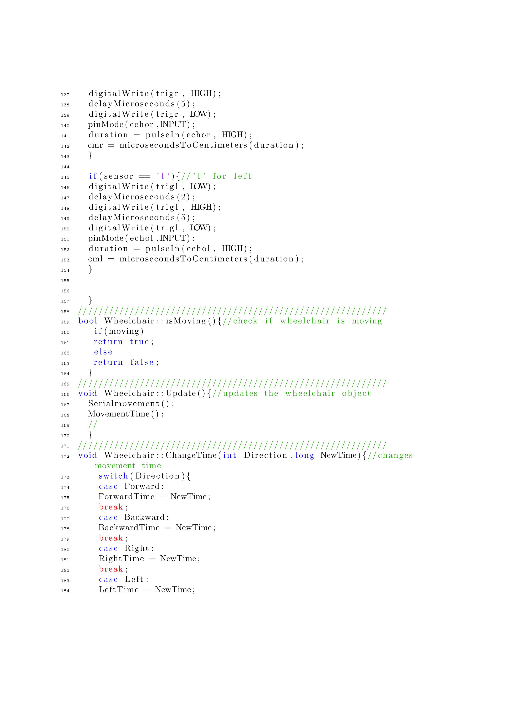

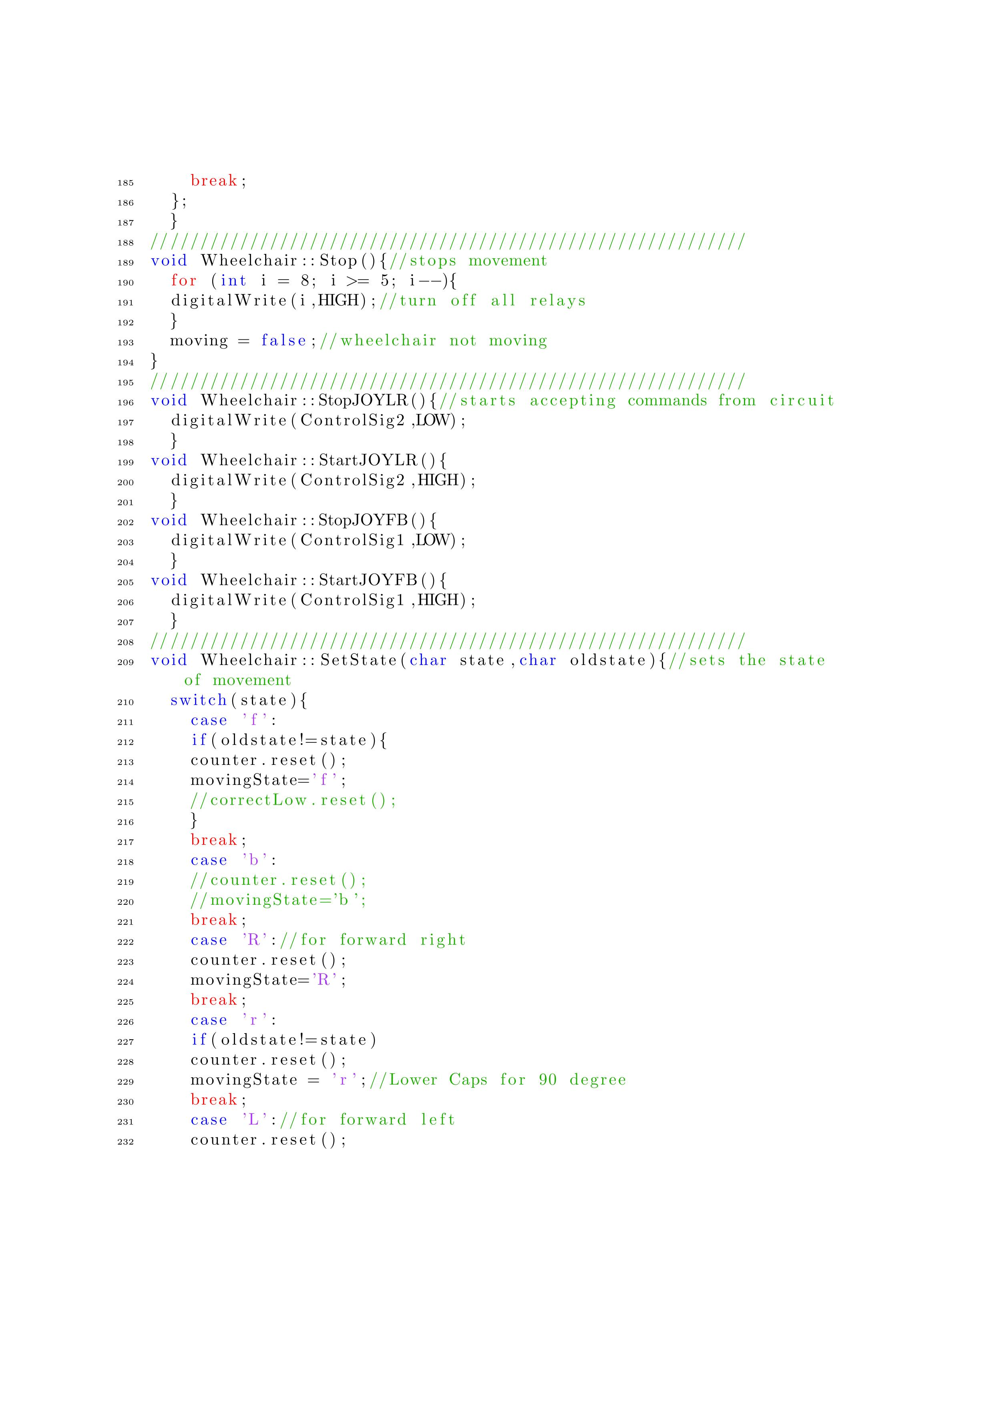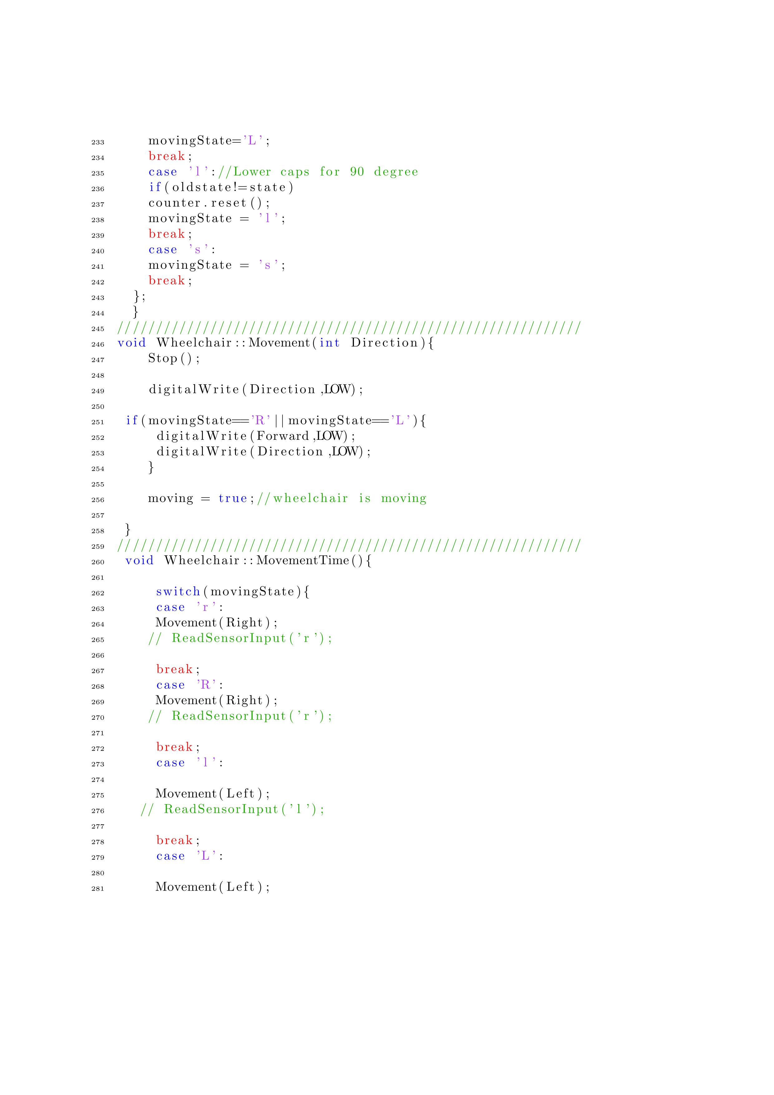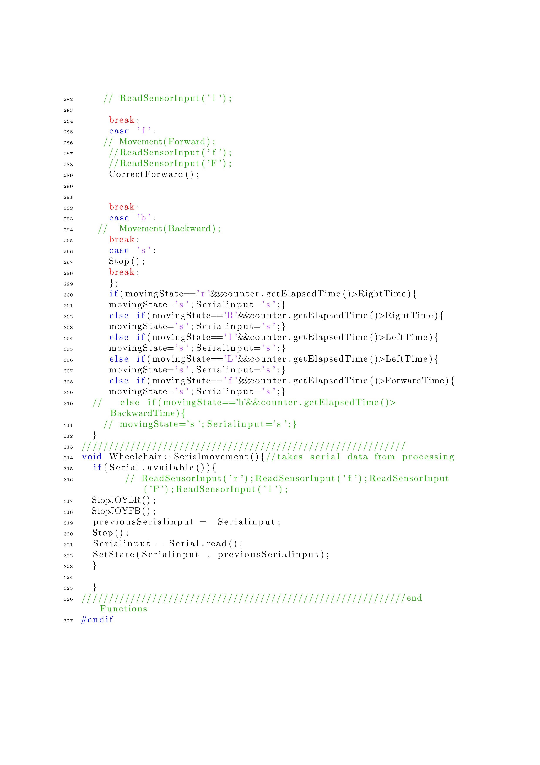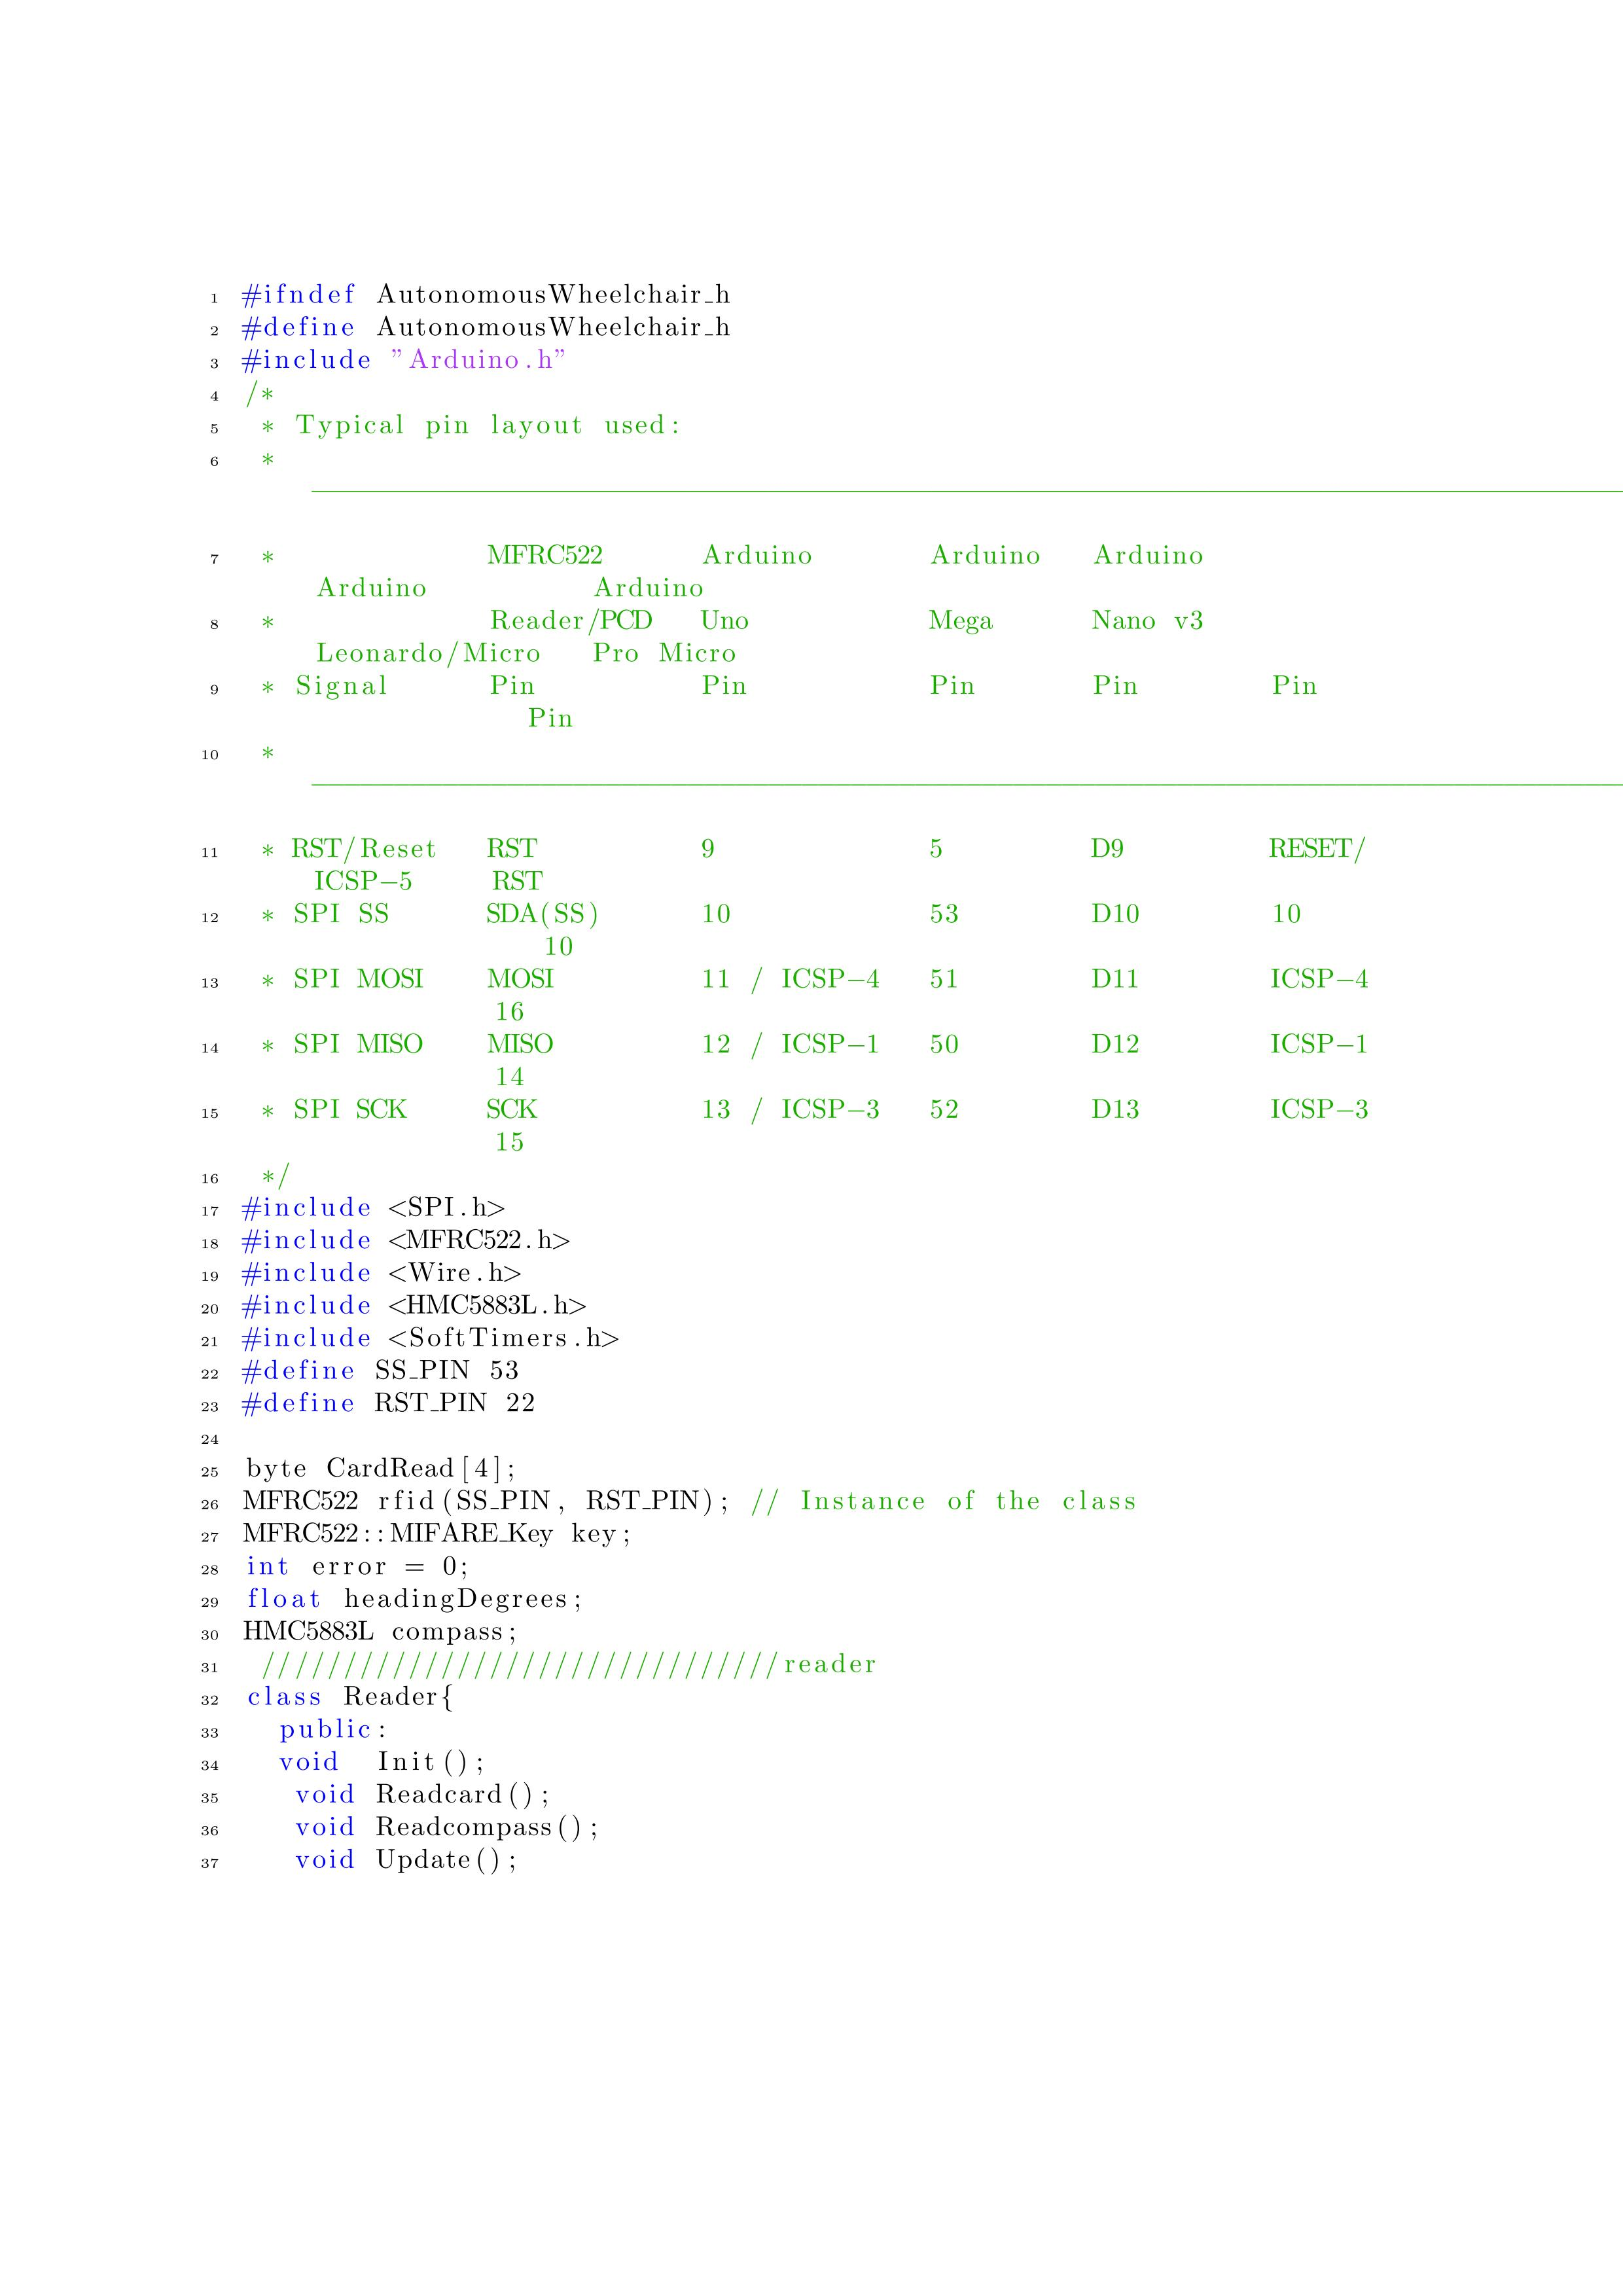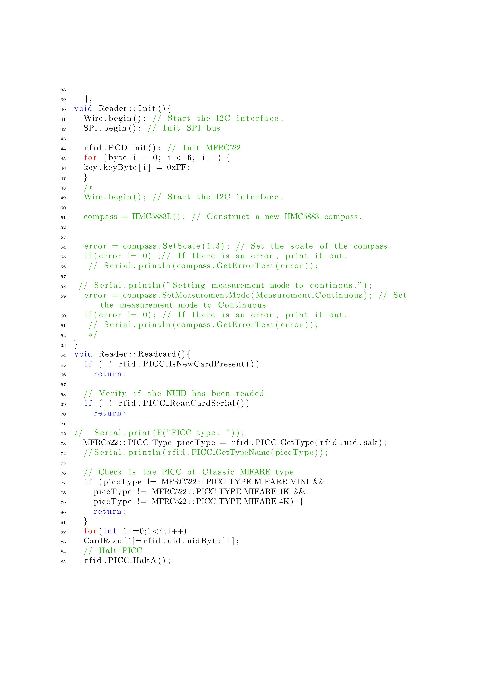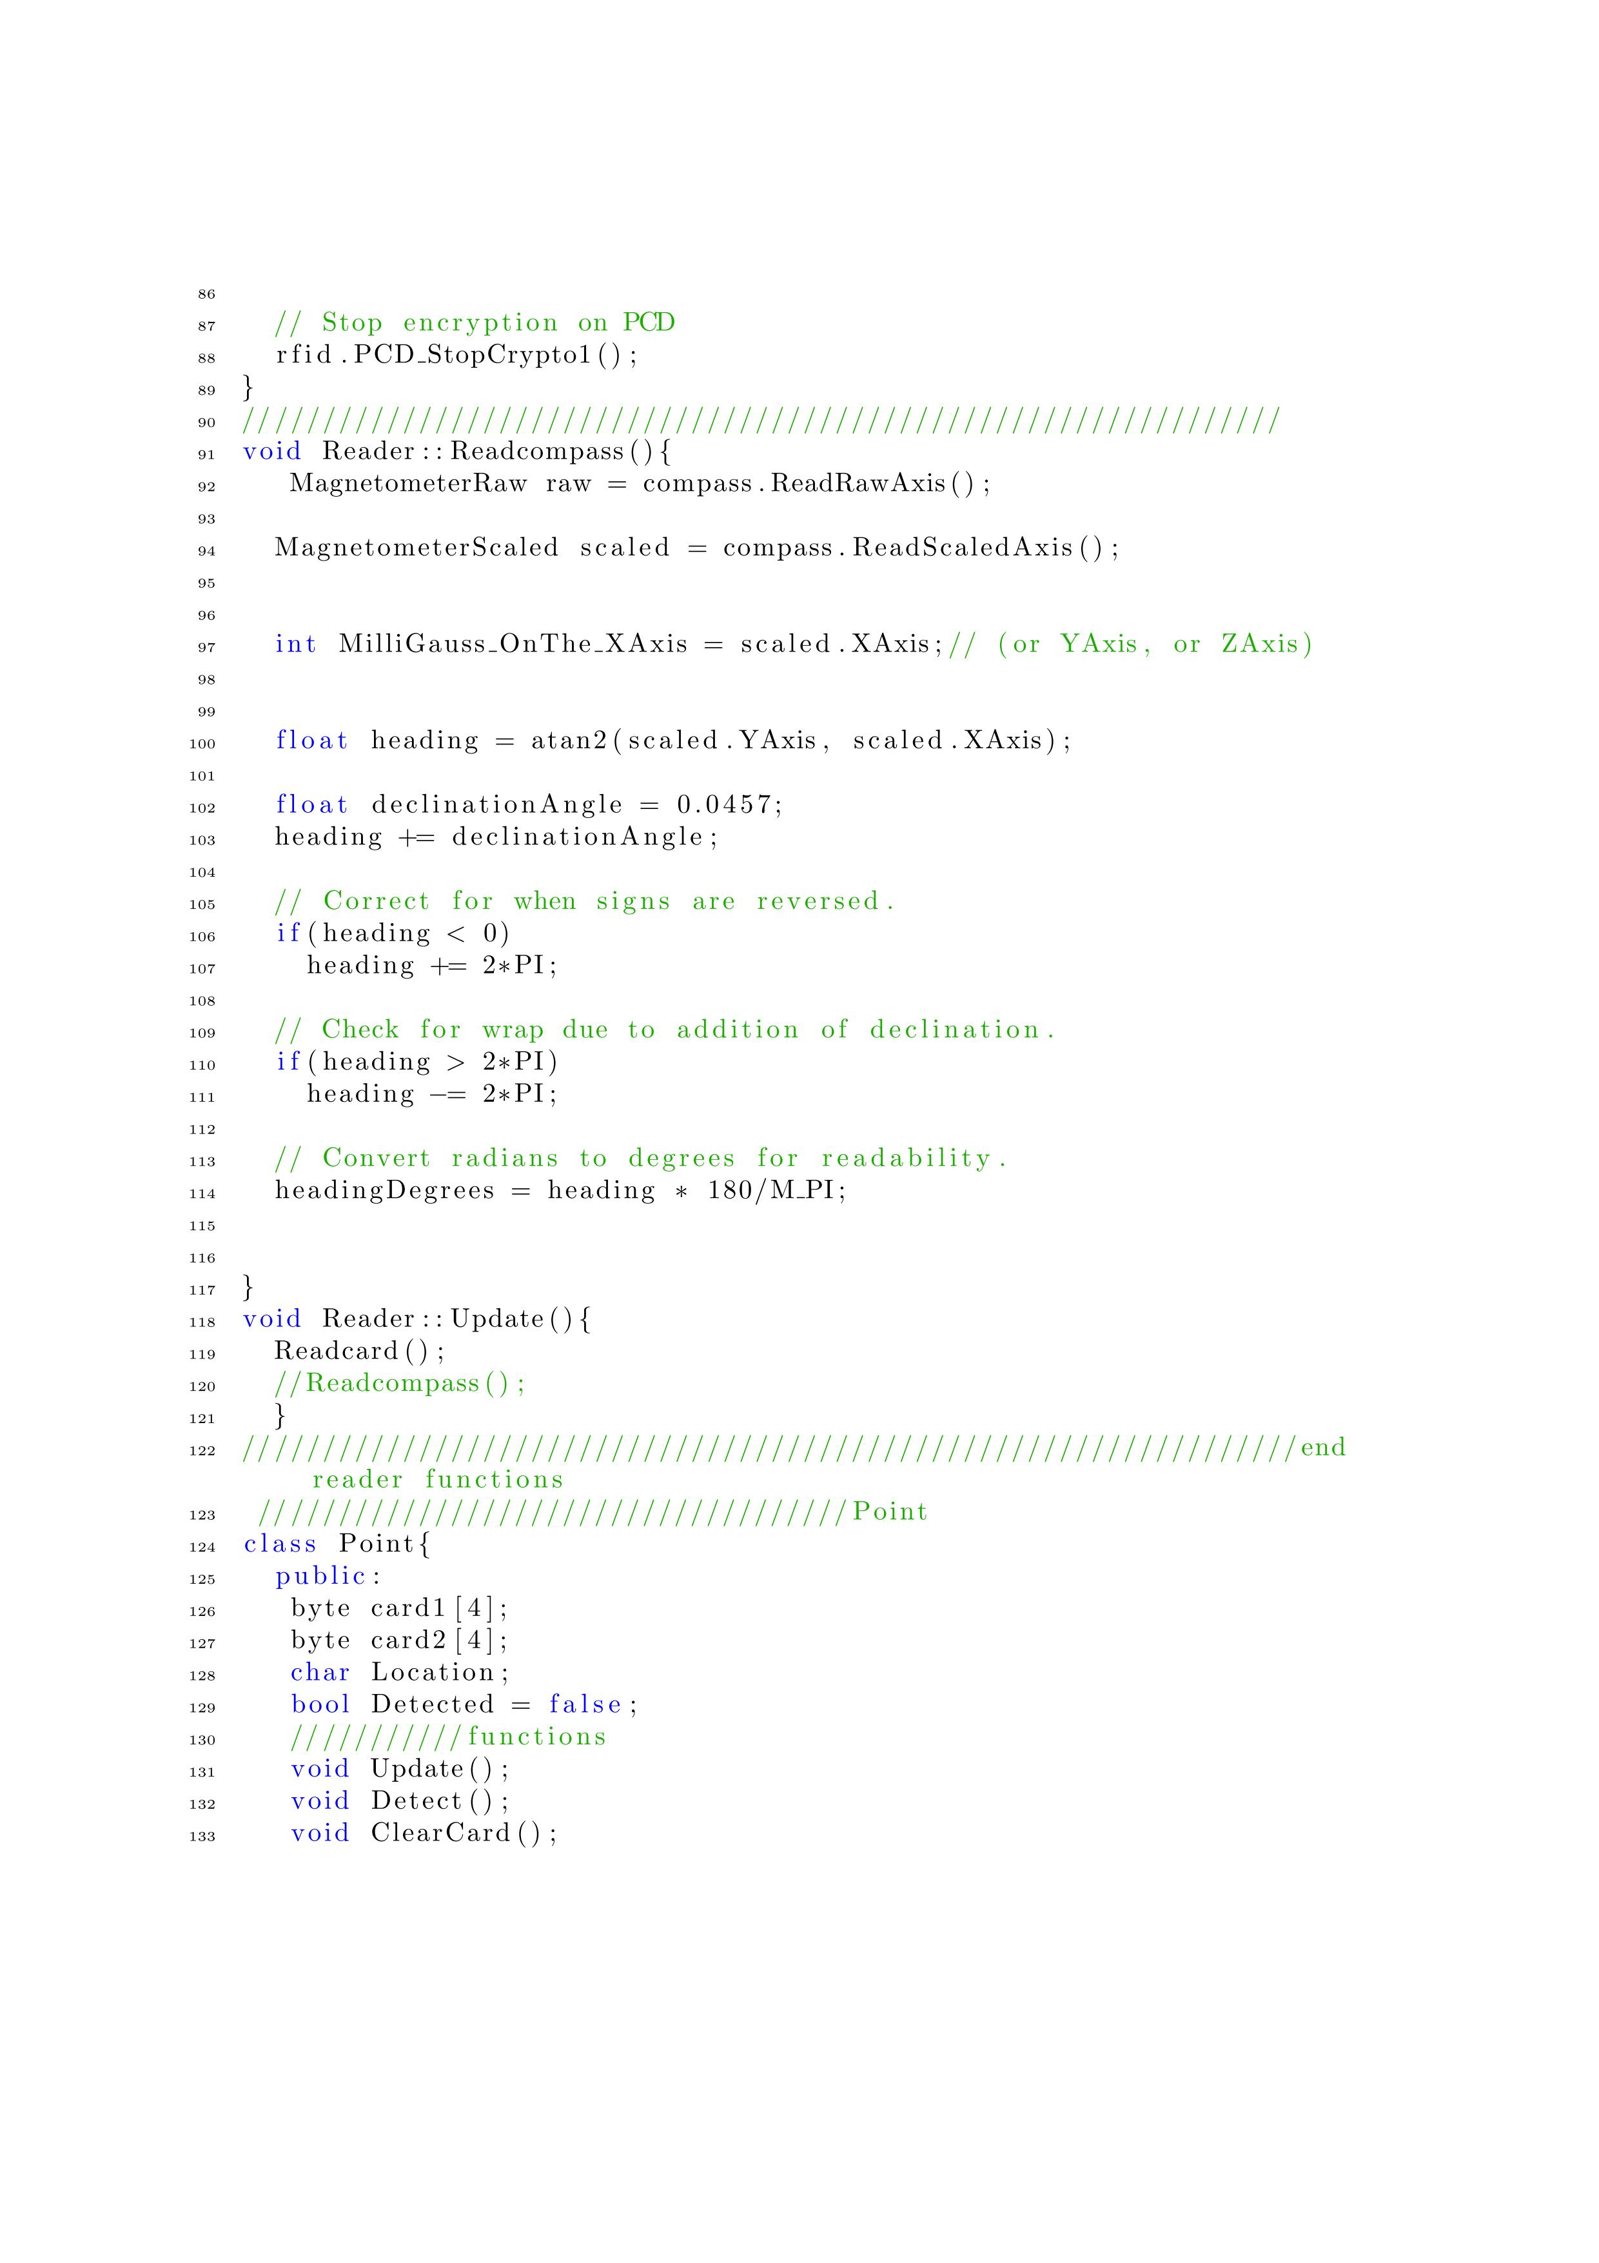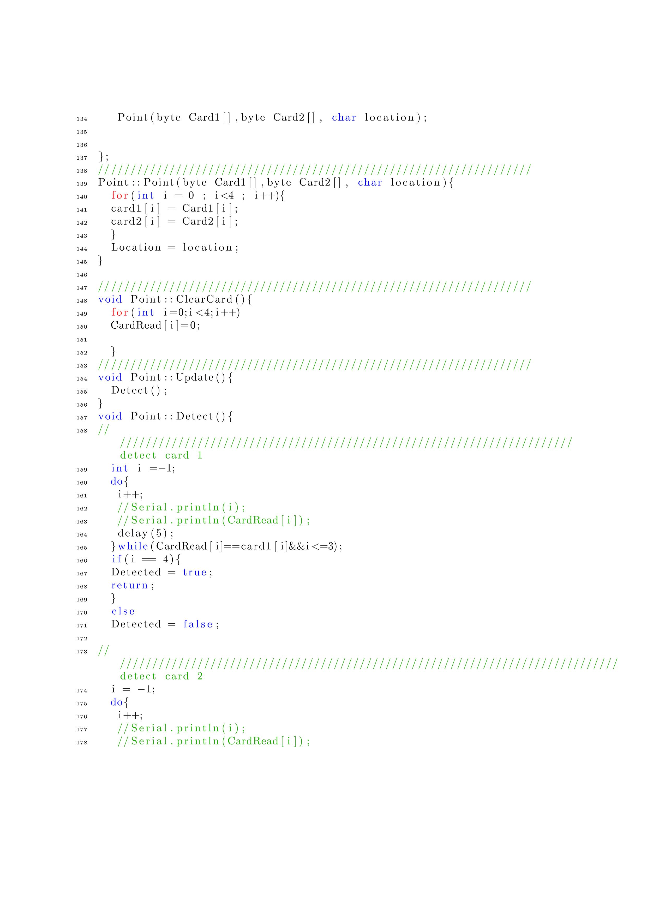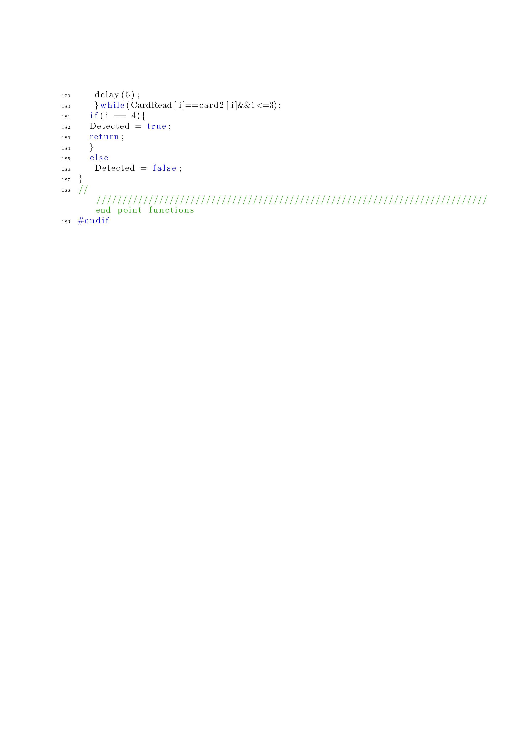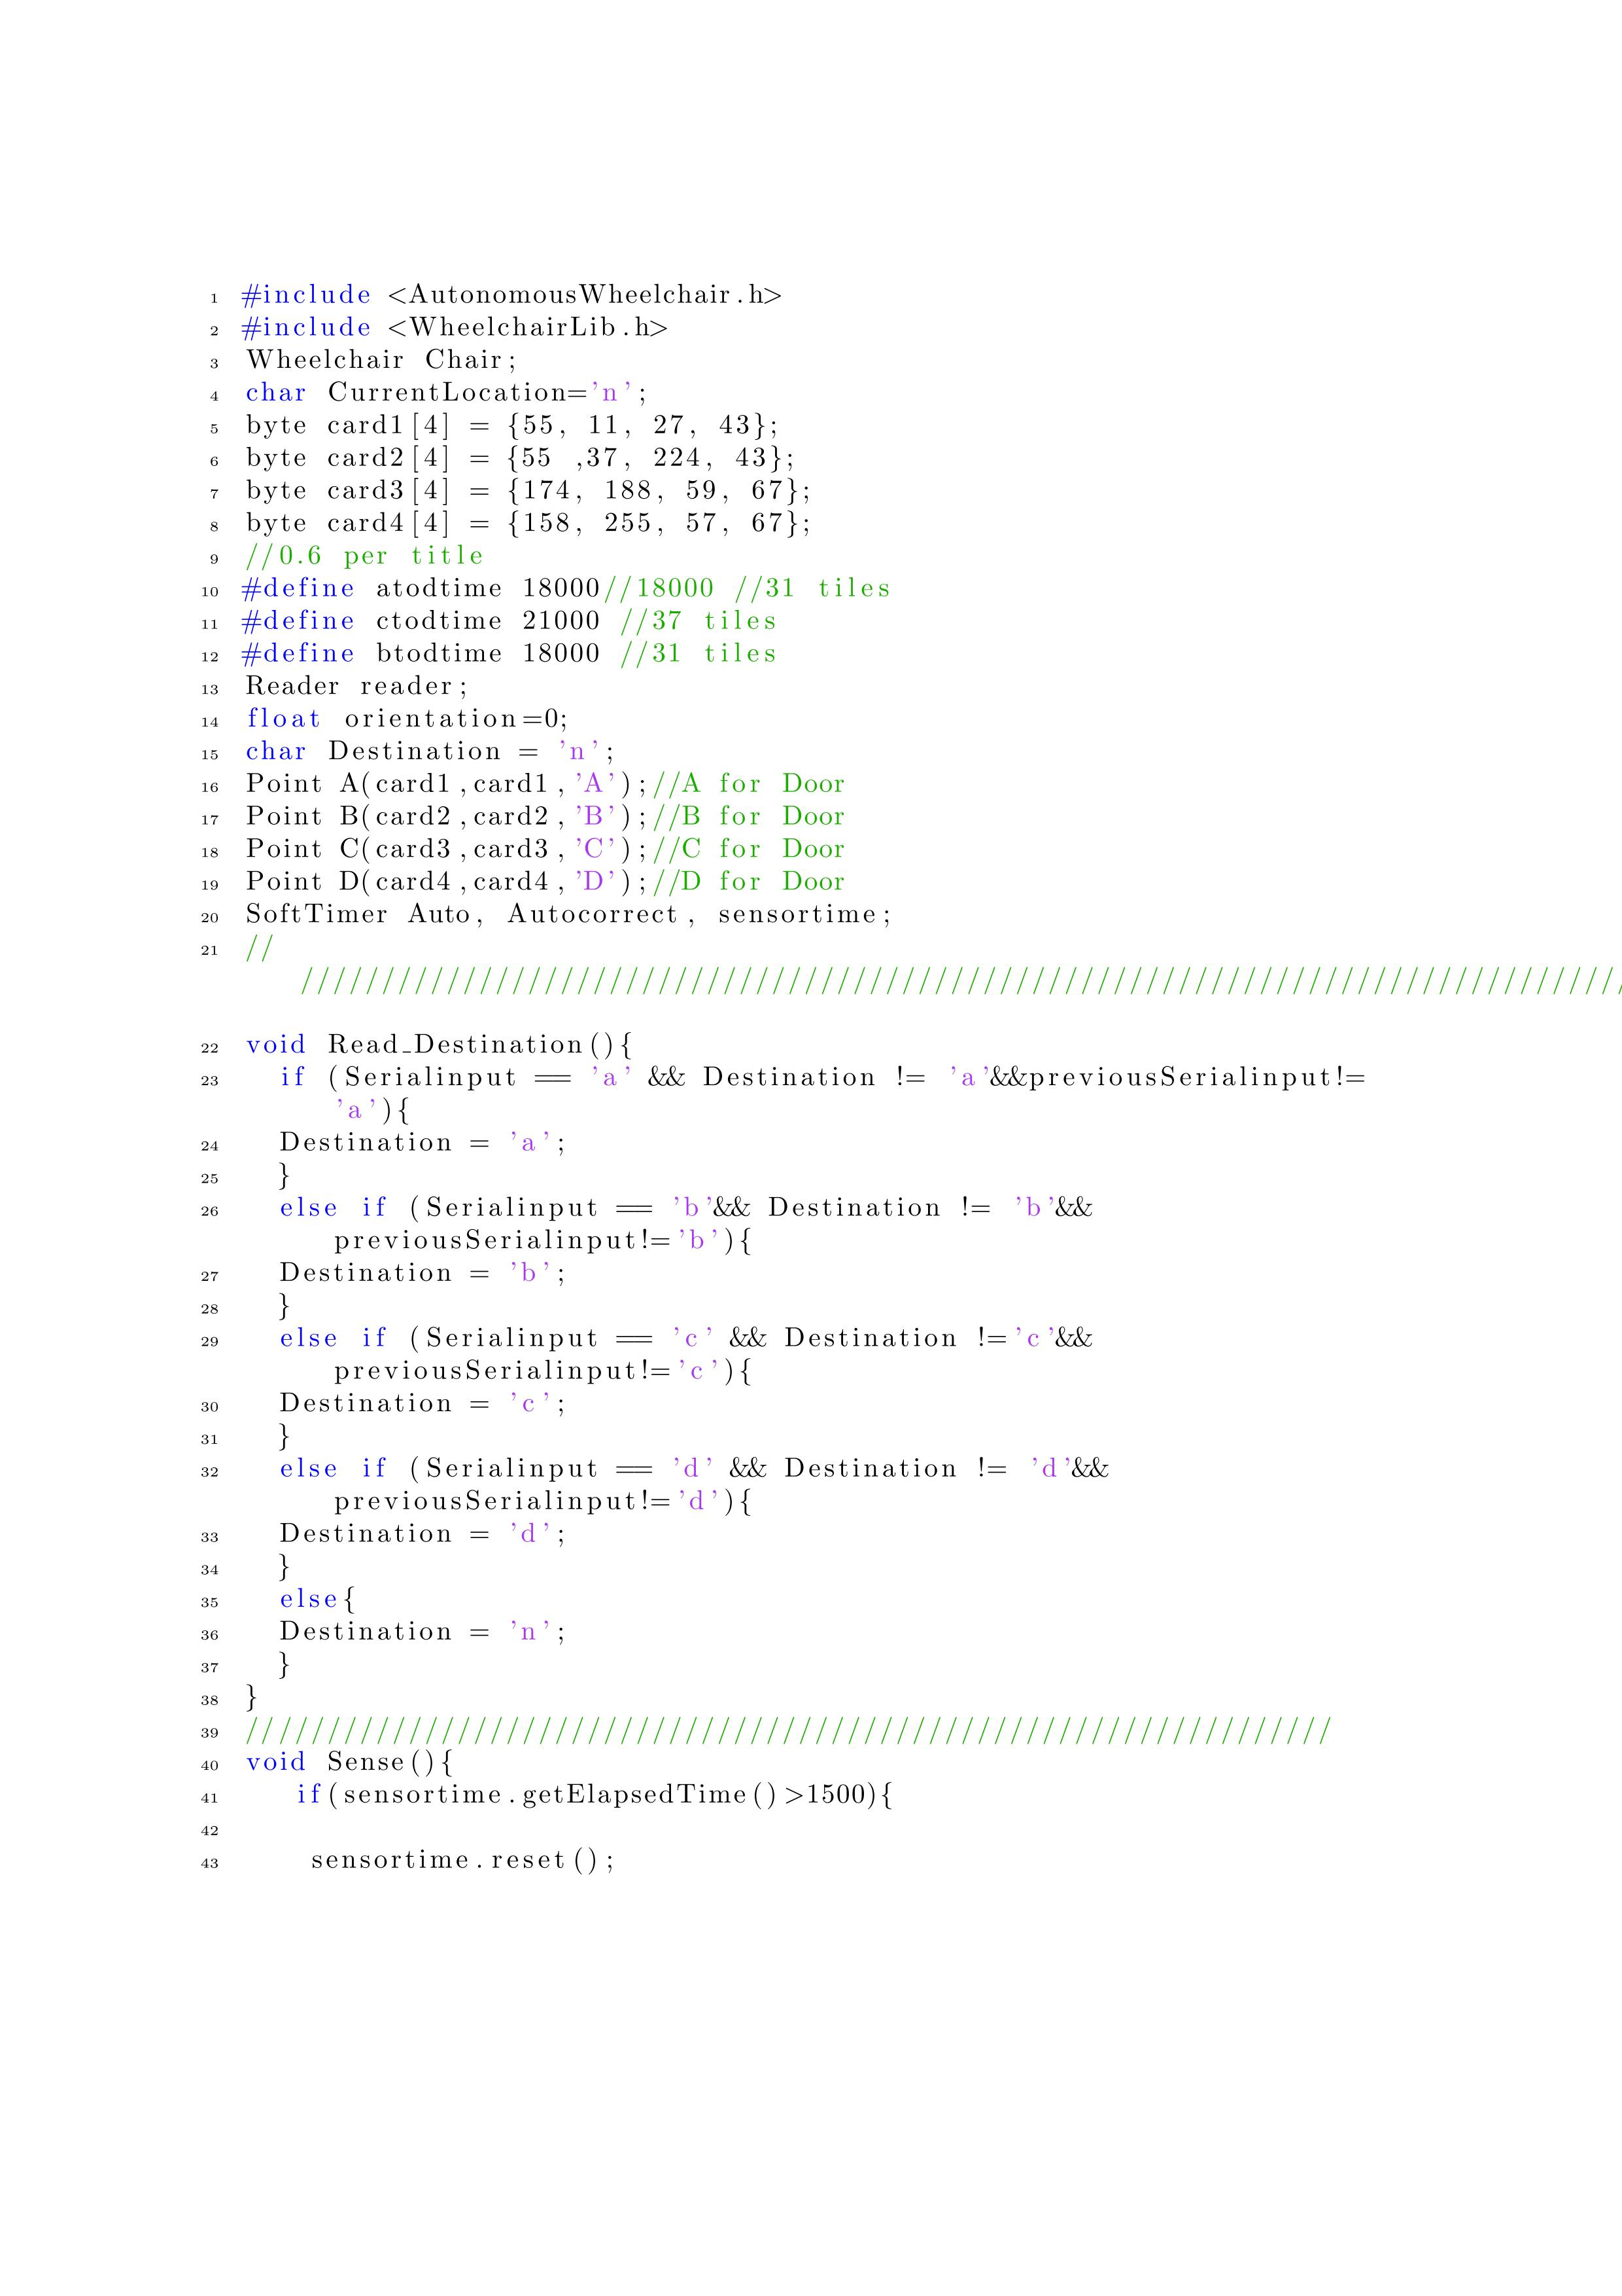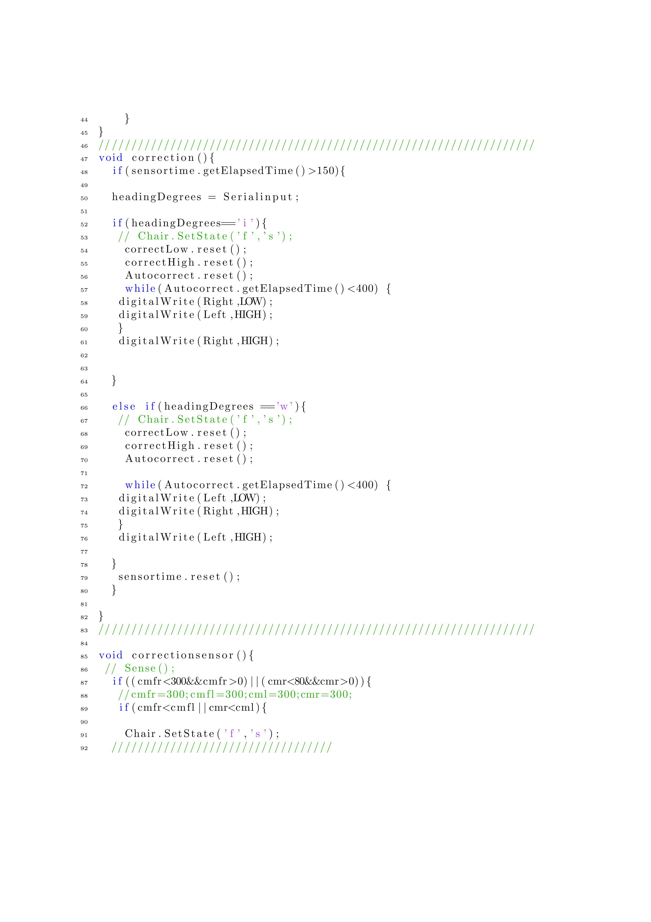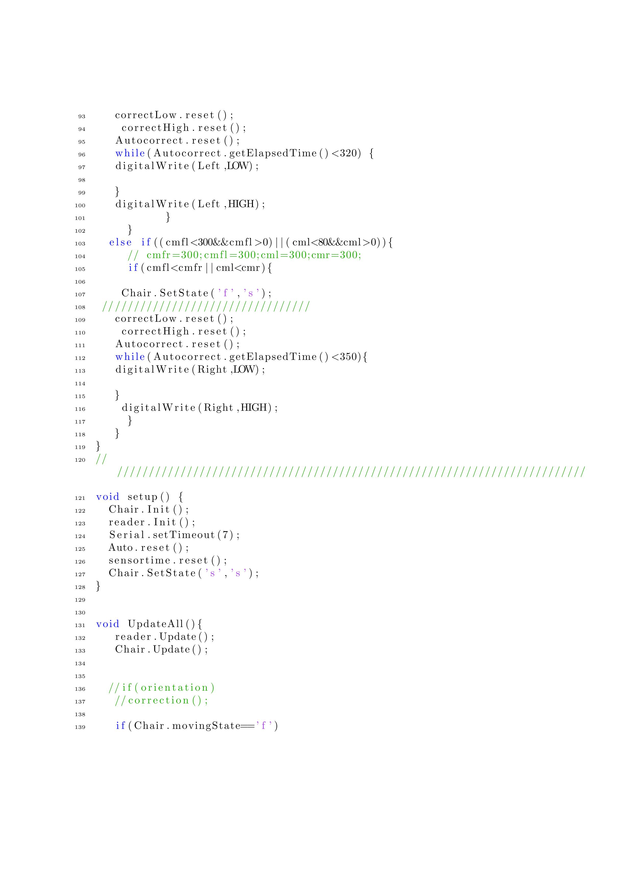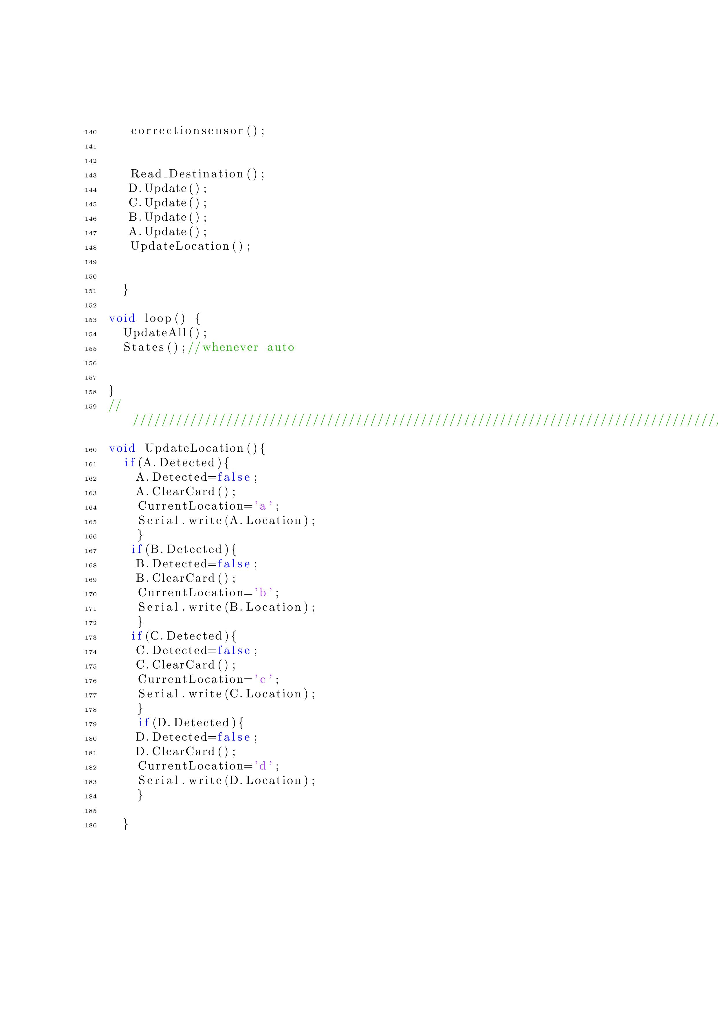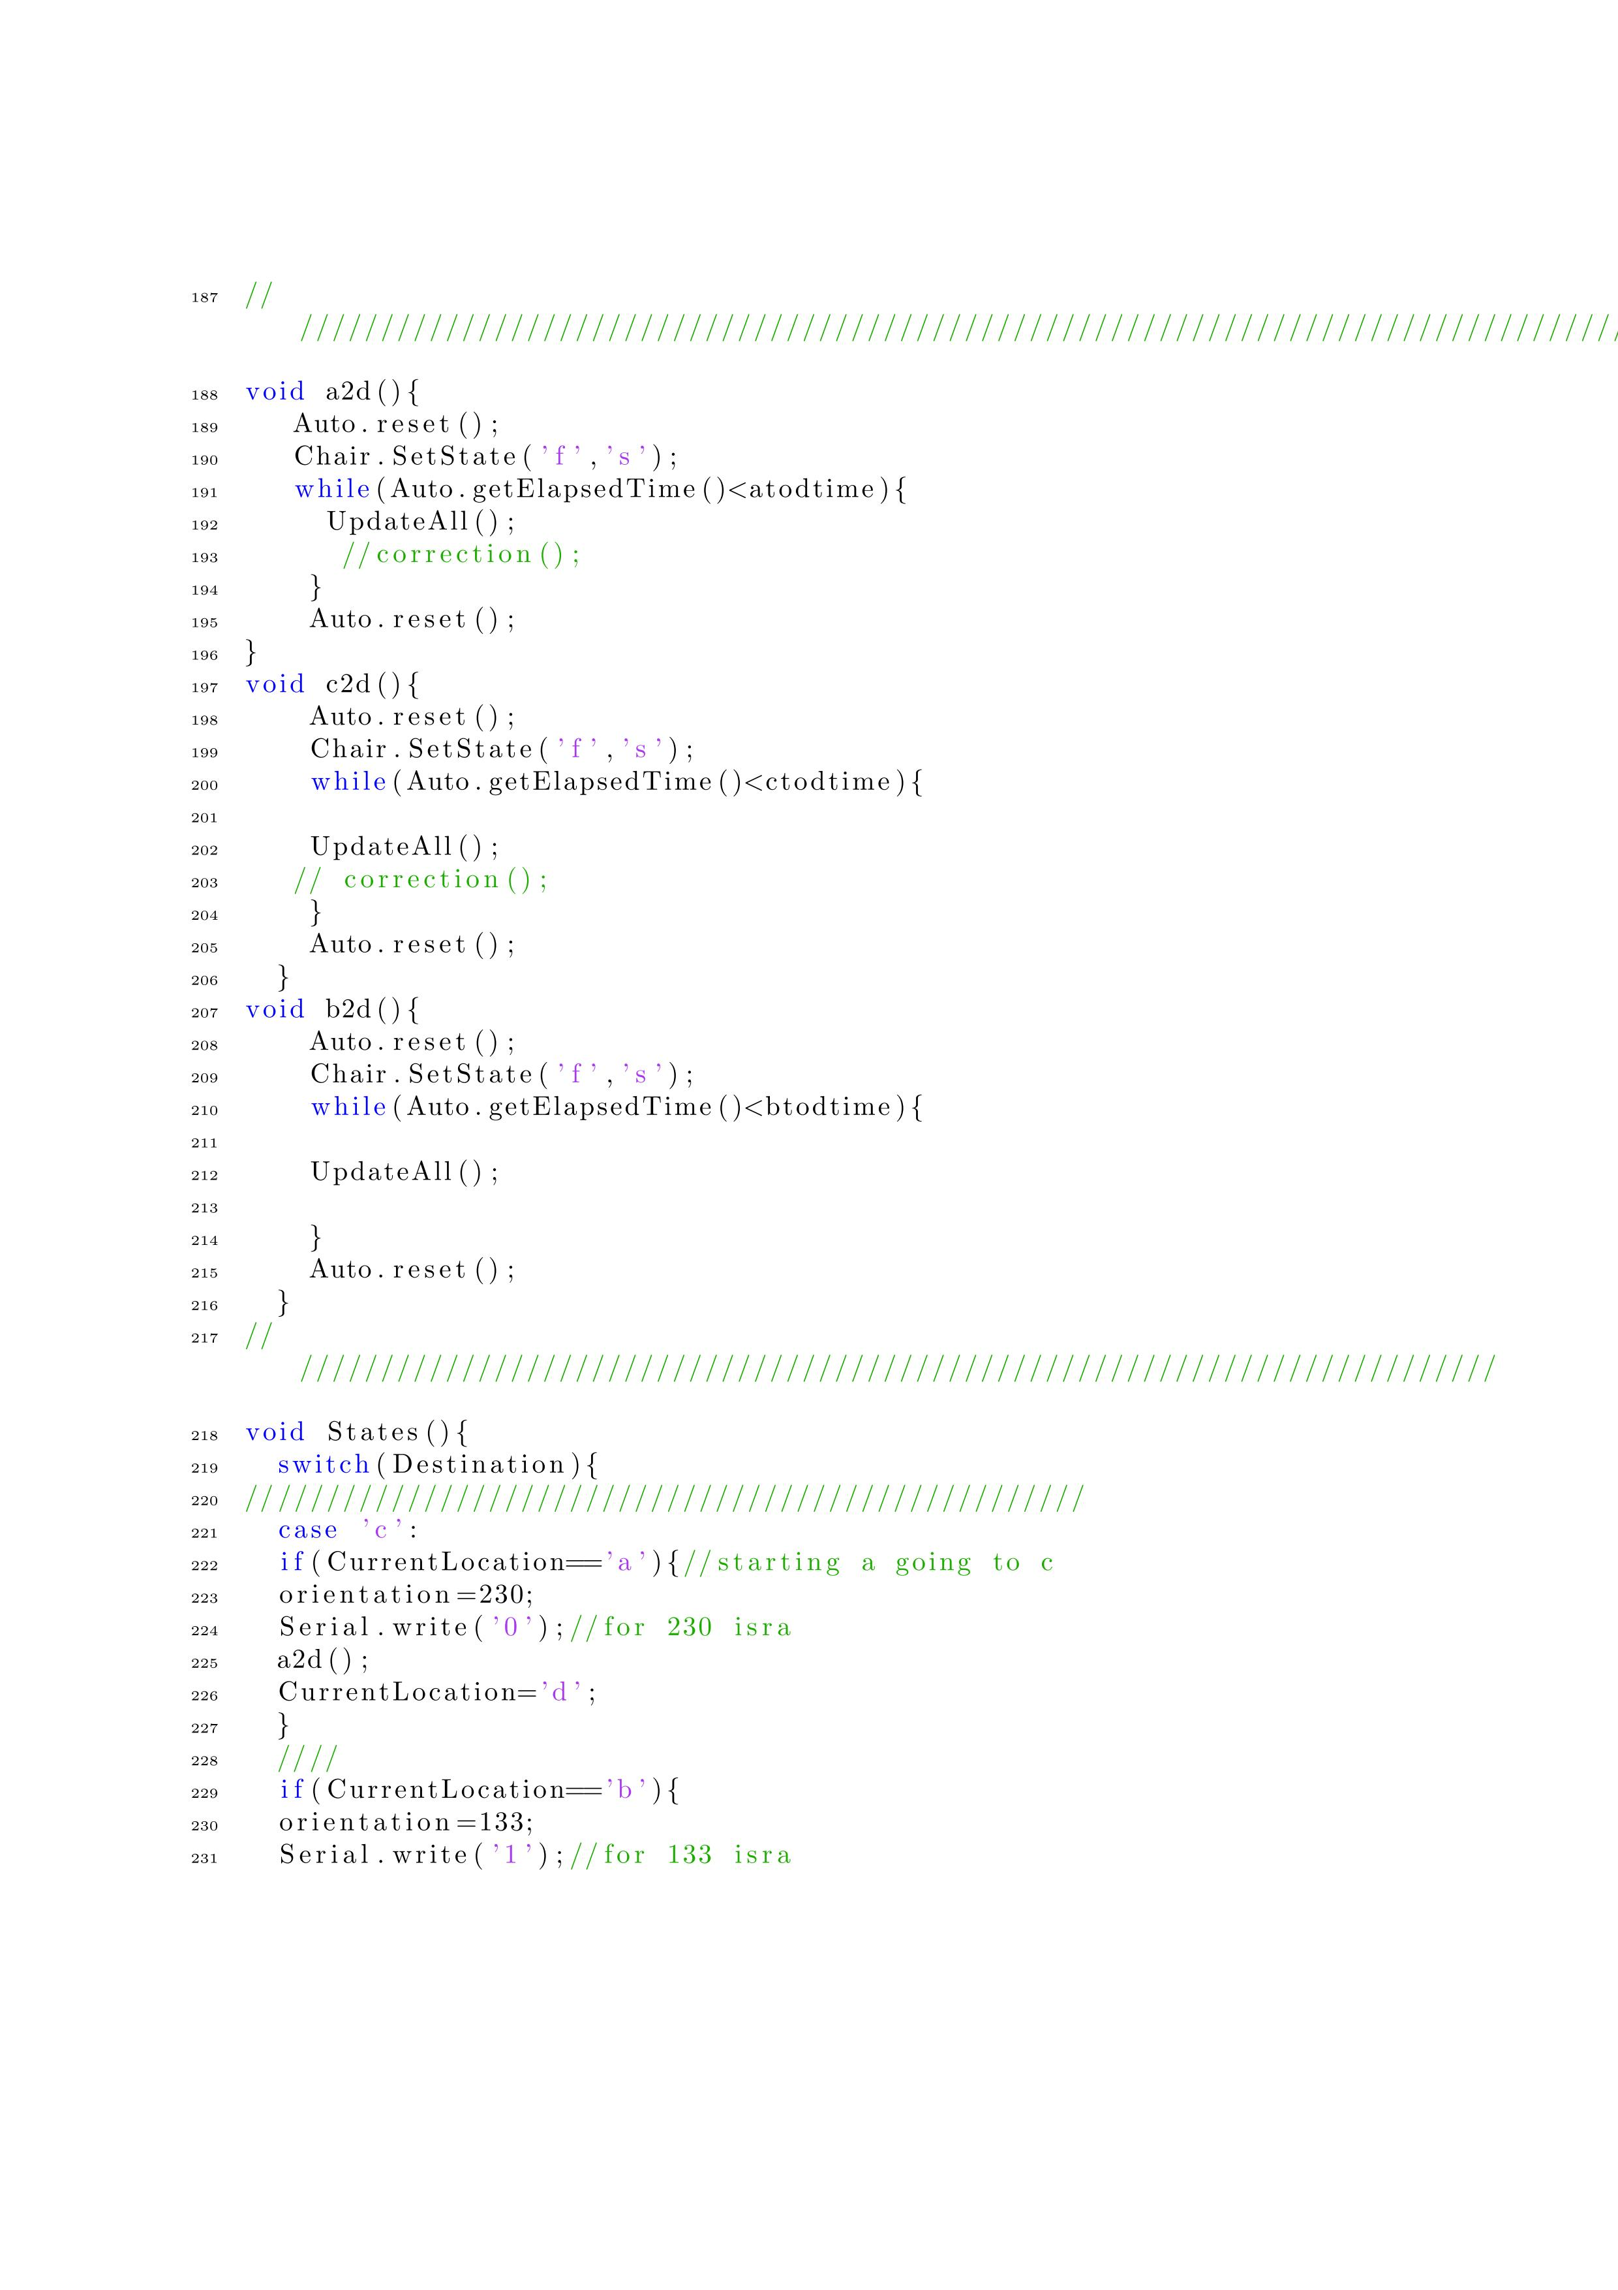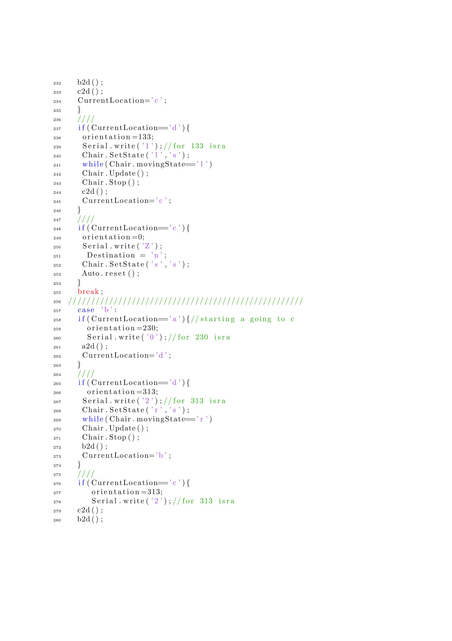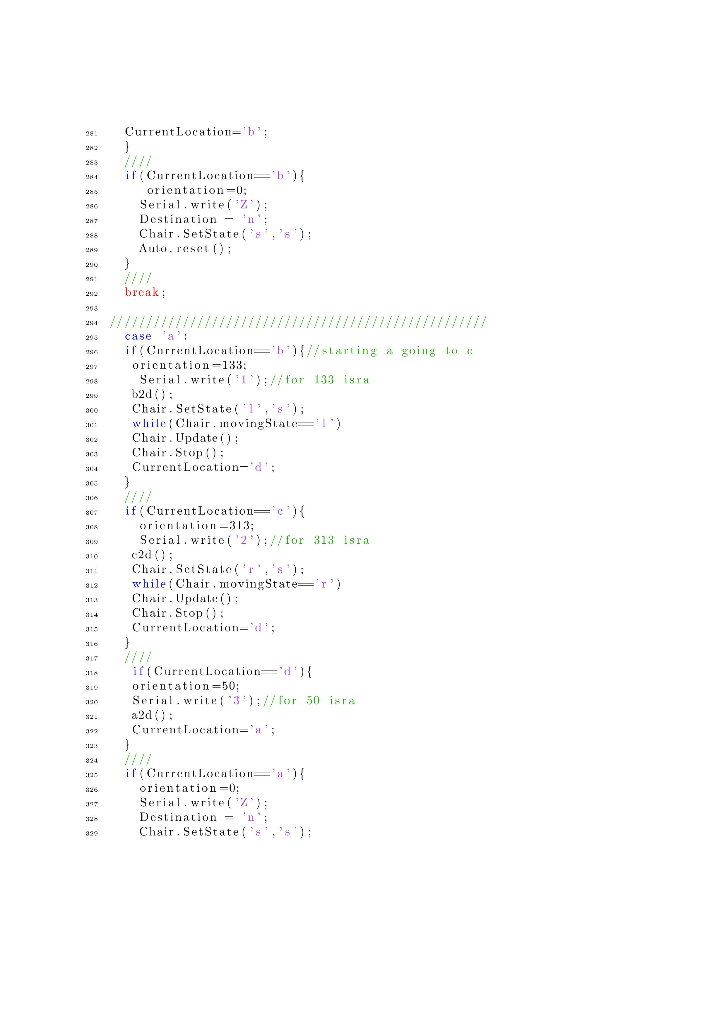

**Appendix B**

**Processing Code**

